Notazioni per split

$$\left\{A,B\right\} , A | B$$

$$\left\{\left\{t,u\right\},\left\{v,w\right\}\right\} , \left\{t,u\right\} \left|\left\{v,w\right\} , t,u \right| v,w , tu | vw$$

Split decomposition: A new and useful approach  
 to phylogenetic analysis of distance data

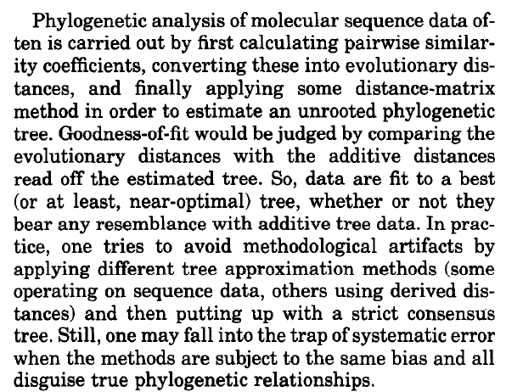pairwise similarity coefficients ->  
evolutionary distance ->  
distance-matrix method ->  
phylogenetic tree

judge result by comparing evolutionary distance with additive distance of the estimated tree

data are “fitted” to a tree (regardless of how tree-like they are)

to avoid bias of the method, use different tree approximation methods  
 (e.g. some on sequence data, some on derived distances),  
then strict consensus tree

still subject to systematic error if all methods share the same bias

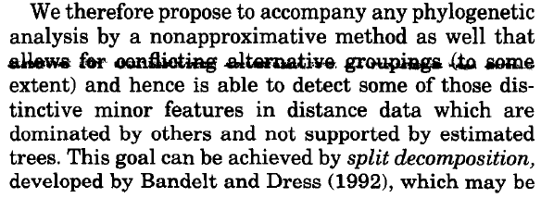 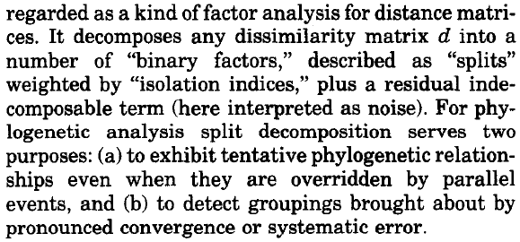

split decomposition allows for conflicting alternative groupings

purposes for phylogenetic analysis:

* exhibit tentative phylogenetic relationships,  
   even when overridden by parallel events
* detect groupings caused by convergence or systematic error

The interpretation of residue as noise/error is questionable: if $d$ is non-negative, then also the residue is non-negative. We may expect that an error term should have both positive and negative elements.   
Actually, it is reasonable to expect even more negative elements, since evolutionary distances underestimate the number of mutations occurred (even when using a correction model, we cannot be sure to have an estimate from above of the true distance).

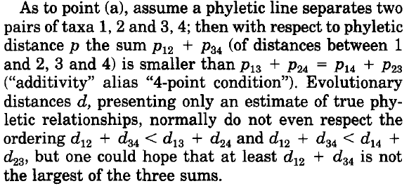 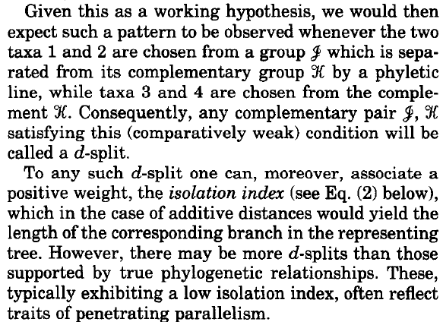

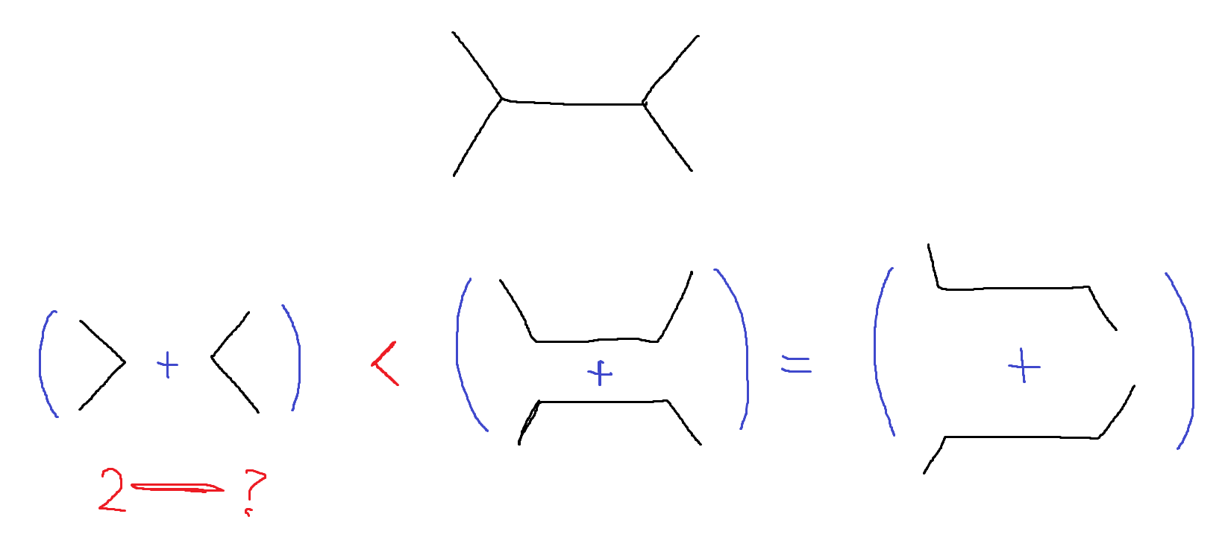

phyletic distance $p$ satisfies the four-point condition:

$$p_{12}+p_{34}<p_{13}+p_{24}=p_{14}+p_{23}$$

evolutionary distance $d$,  
 being only an estimate of true phylogenetic relationships,   
normally does not even respect

$$d_{12}+d_{23}<\begin{matrix}d_{13}+d_{24} \\ d_{14}+d_{23}\end{matrix}$$

but we can hope that $d_{12}+d_{23}$ is not the largest among the three

$$d_{12}+d_{23}<\max{\{d_{13}+d_{24},d_{14}+d_{23}\}}$$

we would expect this condition to hold for every two couples  
 chosen from two groups separated by a phyletic line;  
a split that satisfies this condition is a $d$-split  
 (notice that this equivalent to saying that the isolation index is positive)

for additive distances, the isolation index represents the length of the edge[1]* in the associated tree

there may be more $d$-splits than those supported by true phylogenetic relationships; typically they exhibit a low isolation index, and often reflect traits of parallelism

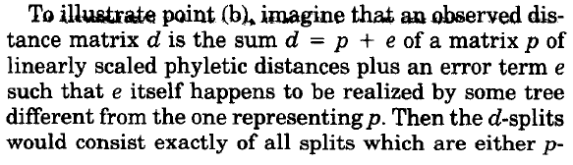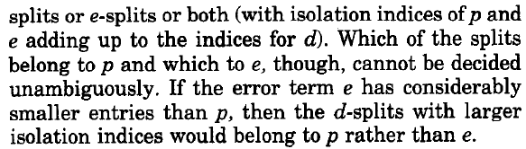

Let $d=p+e$, where $d$ is the observed distance, $p$ the phyletic distance linearly scaled and $e$ an error term such that the trees representing $p$ and $e$ are different. Then

$$\left\{d-splits\right\}=\left\{p-splits\right\}∪\left\{e-splits\right\}$$

$$α^{d}=α^{p}+α^{e}$$

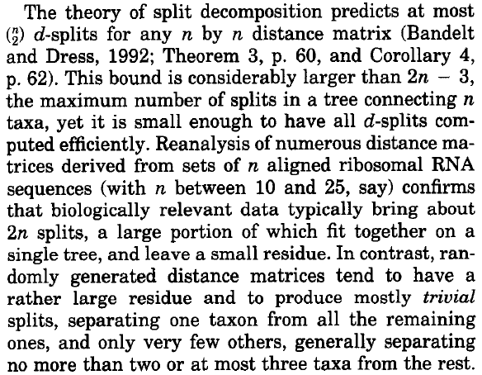max $d$# -splits: $\left({n \atop 2}\right)=\frac{1}{2}n^{2}-\frac{1}{2}n$

max # splits in a tree: $2n-3$

biologically relevant data bring about $2n$ splits, most of them fit on a single tree, and leave a small residue ($10≤n≤25$)

randomly generated distance matrices tend to have large residue and trivial or almost-trivial splits (separate only 2,3 taxa from the rest)

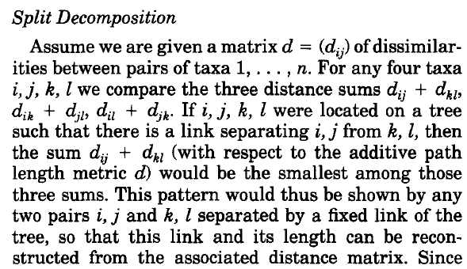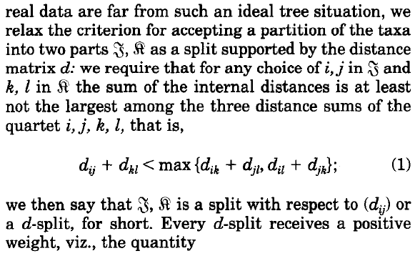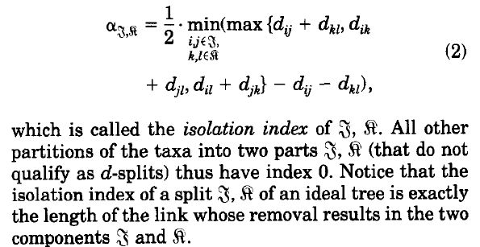

Let $d=(d_{ij})$ be a $n×n$ dissimilarity matrix.

In the case of a tree, for every four taxa $i,j,k,l$,  
 if there is an edge separating $i,j$ and $k,l$, then

$$d_{ij}+d_{kl}<d_{ik}+d_{jl}=d_{il}+d_{jk}$$

This edge can be reconstructed from the associated distance matrix.

A split $J,K$ is a $d$**-split** if for every $i,j∈J$ and $k,l∈K$ we have

$$d_{ij}+d_{kl}<\max\left\{d_{ik}+d_{jl},d_{il}+d_{jk}\right\}$$

This is a relaxed condition representing splits supported by the distance matrix.

The **isolation index** of $J,K$ is the quantity

$$α_{J,K}≔\frac{1}{2}⋅\min_{\begin{aligned}i,j∈J \\ k,l∈K\end{aligned}}\left( \max\left\{d_{ij}+d_{kl},d_{ik}+d_{jl},d_{il}+d_{jk}\right\}-d_{ij}-d_{kl} \right)$$

Notice that $d$-splits have positive isolation index,  
 while non $d$-splits have zero isolation index.

Also, in the case of a tree, the isolation index of a split $J,K$ is the length of the edge separating $J$ and $K$ (that is removing this edge results in two connected components, namely $J$ and $K$).

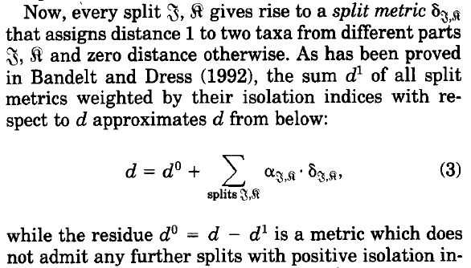 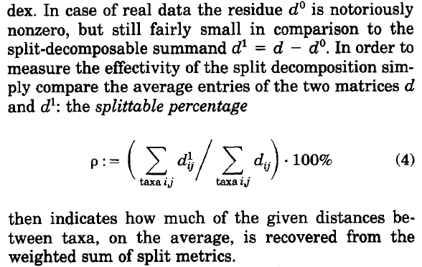

The **split metric** on $J,K$ is the function $δ_{J,K}$ defined as

$$δ_{J,K}(i,j)≔\left\{ \begin{matrix}0 , if i,j∈J or i,j∈K \\ 1 , otherwise\end{matrix}\right.$$

We can write the **split decomposition**

$$d=d^{0}+\sum_{splits J,K}{α_{J,K}⋅δ_{J,K}}$$

where the residue $d^{0}=d-d^{1}$ is a **split-prime** dissimilarity matrix  
 (that is it does not admit any $d^{0}$-split).

For real data, the residue $d^{0}$ is non-zero but small compared to $d^{1}$.

The **splittable percentage** is

$$ρ≔\left({\sum_{taxa i,j}{d_{ij}^{1}}}/{\sum_{taxa i,j}{d_{ij}}}\right)⋅100\%$$

This quantity represents how much $d$ is recovered from $d^{1}$, on average.

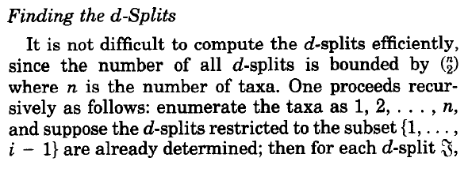  
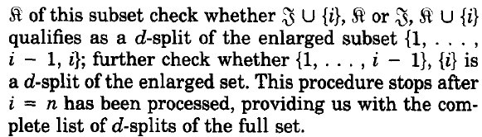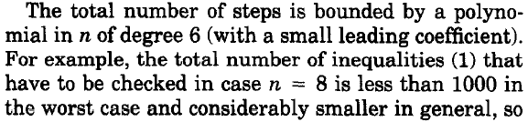

Since the number of $d$-splits is at most $\left({n \atop 2}\right)$,  
we can compute them in the following way:

suppose the $d$-splits on $\left\{1,…,i-1\right\}$ have been already determined;  
then for each $d$-split $J,K$ of this subset

* check if $J∪\left\{i\right\},K$ or $J,K∪\left\{i\right\}$ are $d$-splits of $\left\{1,…,i\right\}$
* check if $\left\{1,…,i-1\right\},\left\{i\right\}$ is a $d$-split of $\left\{1,…,i\right\}$

This procedure leads to an algorithm of complexity $O(n^{6})$.

Dovrebbe essere meno di 1000 $β$ indici per $n=7$.

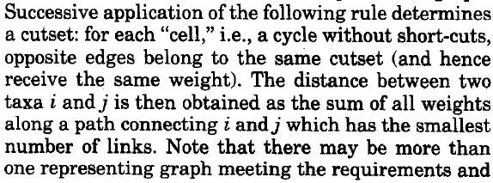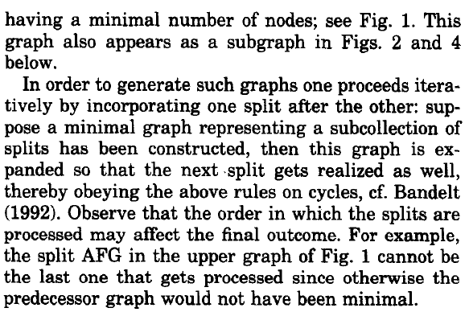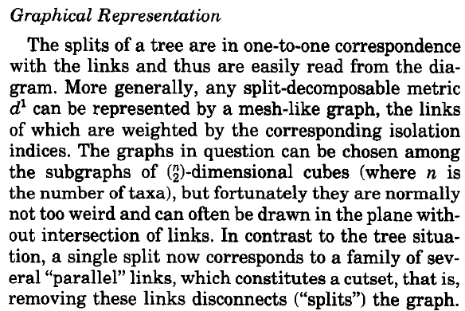

the splits of a tree are in correspondece with its edges

a split-decomposable metric can be represented by a mesh-like graph, where its edges are weighted by the corresponding isolation indices

the graph can be chosen among the subgraphs of $\left({n \atop 2}\right)$-dimensional cubes;  
often they can be drawn in the plane without intersections of edges

now a single split corresponds to a family of “parallel” edges, which constitutes a cutset, that is removing these edges disconnects (“splits”) the graph

for each “cell” (a cycle without short-cuts), opposite edges belong to the same cutset, hence they have the same weight

the distance between two taxa is the sum of the weights of a path with the minimal number of edges

there may be more than one graph meeting the requirements and with minimal number of nodes

non è chiaro l’algoritmo per costruire un grafo minimo

the order in which splits are processed may affect the final outcome

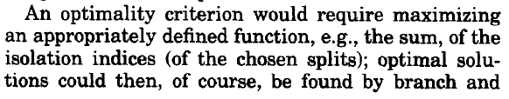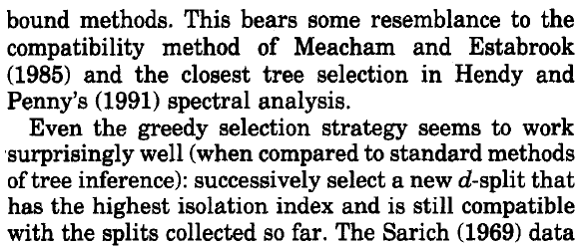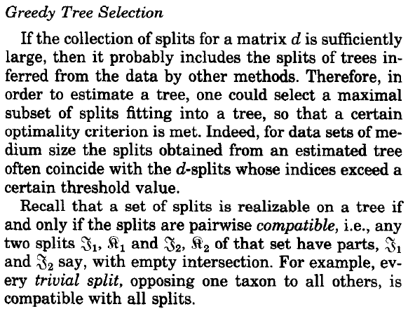

if the set of $d$-splits is large enough, then it probably includes the splits of trees inferred by other methods

in order to estimate a tree, we can select a maximal subset of $d$-splits fitting into a tree according to a certain optimality criterion

for data sets of medium size, the splits obtained from estimated trees often coincide with the $d$-splits with high isolation index

a set of splits is realizable on a tree if and only if they are pairwise **compatible**, that is for any two splits $J_{1},K_{1}$ and $J_{2},K_{2}$ at least one of the following intersections is empty

$$J_{1}∩J_{2} , J_{1}∩K_{2} , K_{1}∩J_{2} , K_{1}∩K_{2}$$

every trivial split is compatible with all splits

an optimality criterion would require maximizing an appropriately defined function (for example sum of isolation indices);  
optimal solutions could be found by branch and bound methods

even greedy selection works well (compared with standard methods of tree inference): select a new $d$-split with highest isolation index that is still compatible with the previous ones

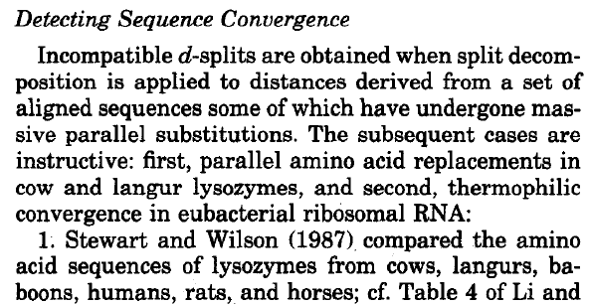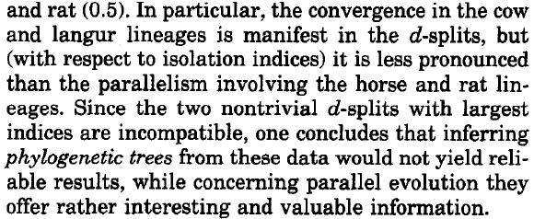

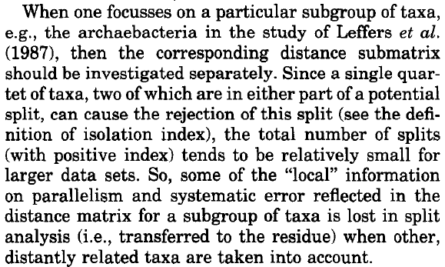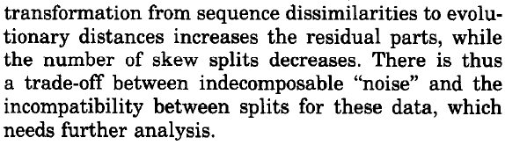

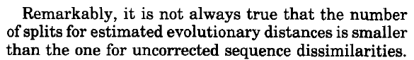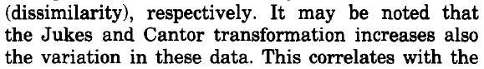

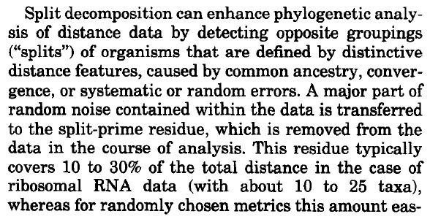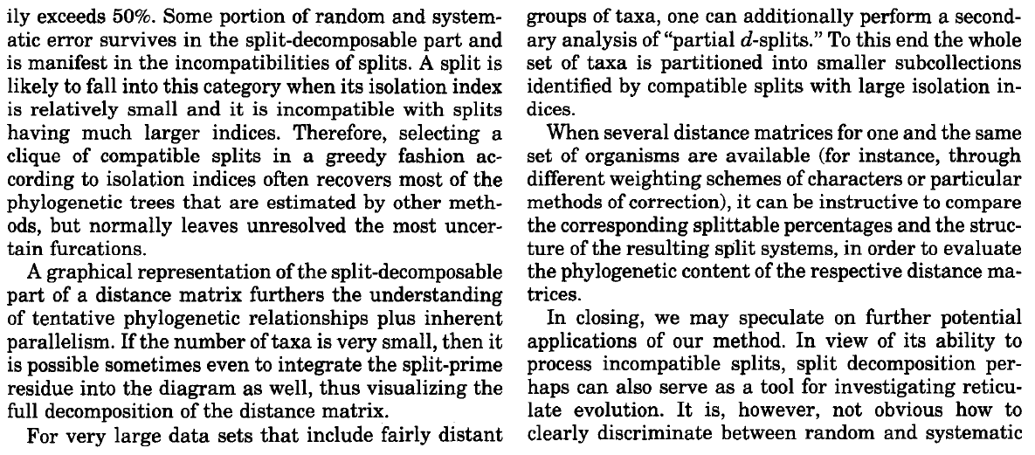

Phylogenetic Networks:  
Concepts, Algorithms and Applications

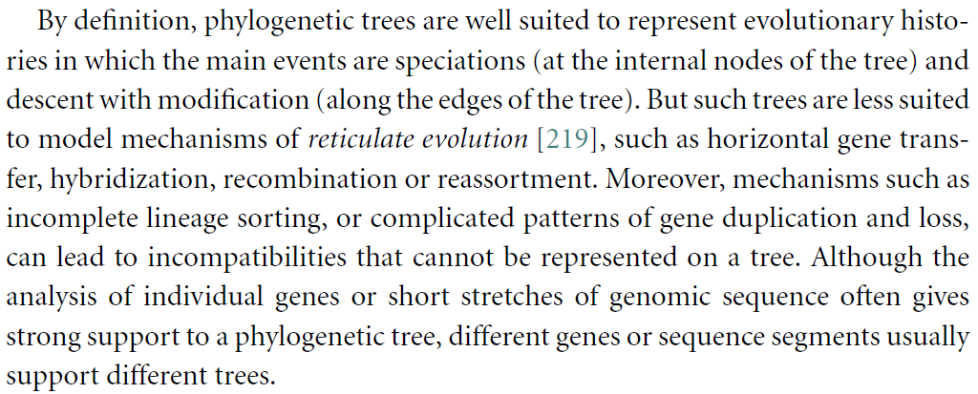

horizontal/lateral gene transfer:

* direct transfer of genes from one organism to another
* occur very frequently in prokaryotes
* main mechanisms are transformation, conjugation, transduction

hybridization:

* each cell has genetic material from two organisms of different varieties/species/genera

recombination (and gene conversion):

* new combinations of genetic material through pairing and shuffling of very similar DNA sequences
* studied by population genetics, which deals with the statistical analysis of the inheritance and prevalence of genes in populations

reassortment:

* involves swapping of genetic material between individual organisms
* occurs for example in viruses

incomplete lineage sorting:

* the tree of a single gene differs from the species tree

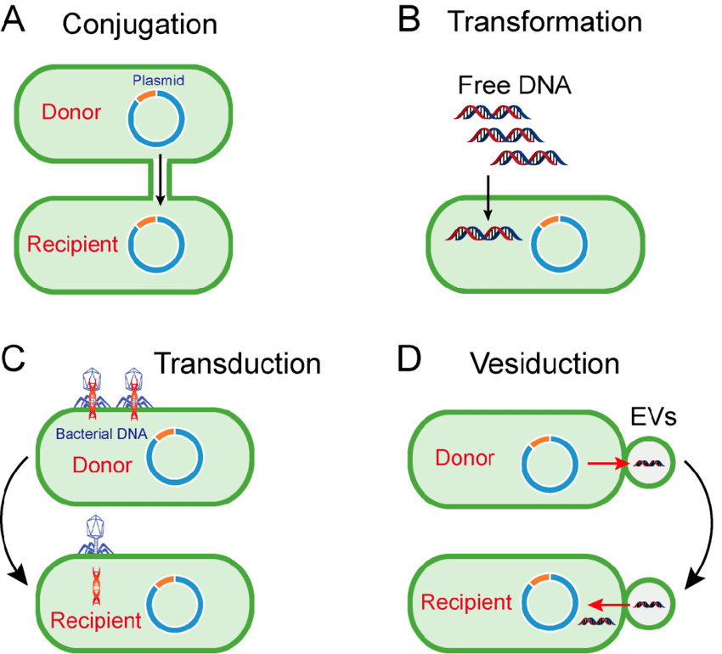

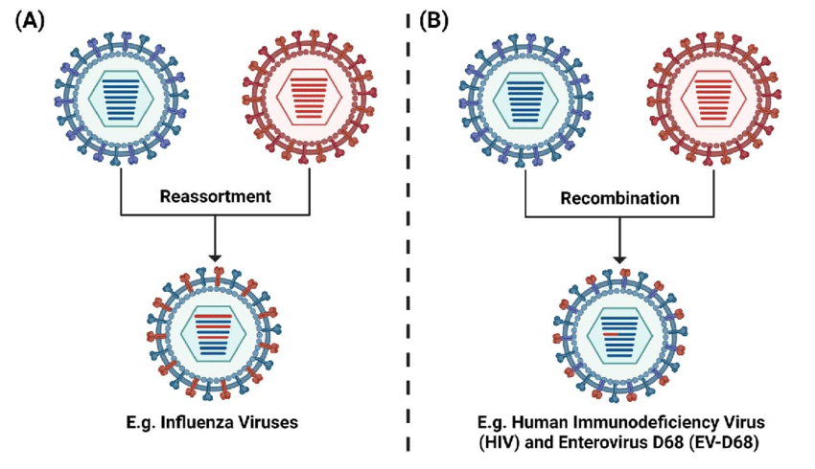

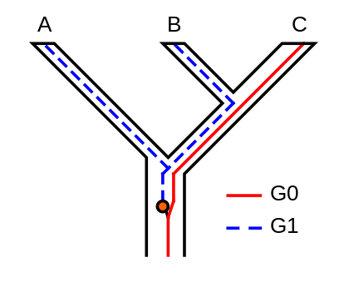

The persistence of polymorphisms across different speciation events can cause **incomplete lineage sorting**.  
Suppose two subsequent speciation events occur where an ancestor species gives rise firstly to species A, and secondly to species B and C.

When studying a single gene, it can have multiple versions (alleles) causing different characters to appear (polymorphisms).   
In the example shown in Figure 1, the gene G has two versions (alleles), G0 and G1.   
The ancestor of A, B and C originally had only one version of gene G, G0.

At some point, a mutation occurred and the ancestral population became polymorphic, with some individuals having G0 and others G1.   
When species A split off, it retained only G1, while the ancestor of B and C remained polymorphic. When B and C diverged, B retained only G1 and C only G0; neither were now polymorphic in G.

The tree for gene G shows A and B as sisters, whereas the species tree shows B and C as sisters.   
If the phylogeny of these species is based on gene G, it will not represent the actual relationships between the species.   
In other words, the most related species will not necessarily inherit the most related genes.

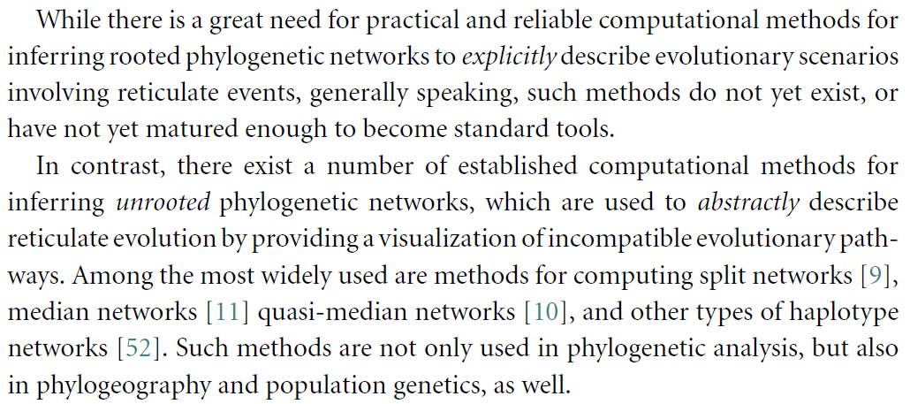

**taxon**: taxonomic unit that represents some species/group/individual organism whose evolutionary history is of interest

**clade** (or **monophyletic group**): a group of organisms that contains all and only the descendants of a common ancestor and the ancestor itself

**paraphyletic group**: a group of organisms that does not contain all species descended from the last common ancestor of all its members

**polyphyletic group**: a group of organisms that consists of species that are descended from multiple last common ancestors, which each have other descendants that are not contained in the group

Let $X$ be a set of taxa.

A **cluster** is any non-empty proper subset of $X$.

A **split** is a partition of $X$ into two non-empty subsets $A,B⊆X$  
 such that $A∩B=∅$ and $A∪B=X$.

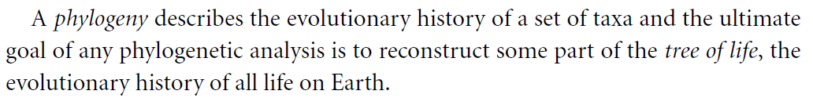

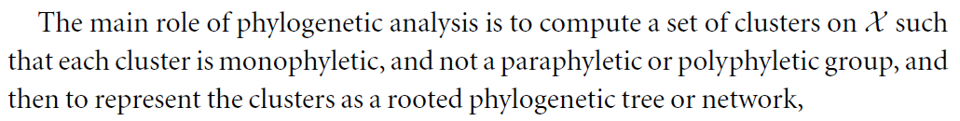

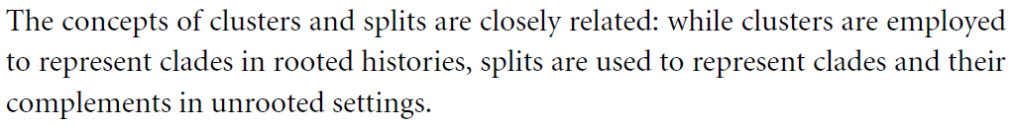

**Sequence alignment**

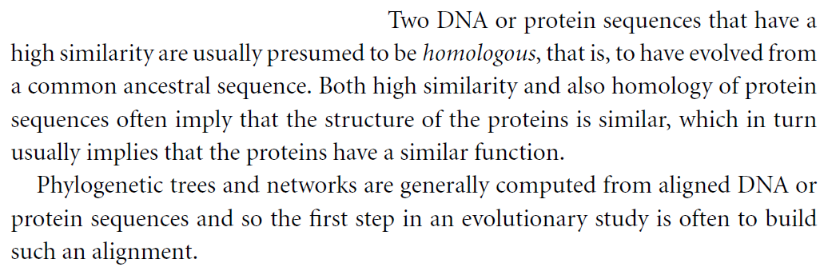

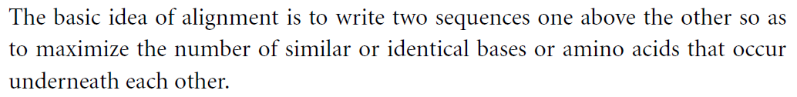

**Pairwise sequence alignment**

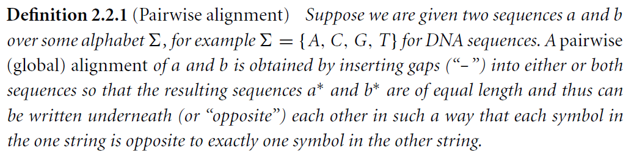

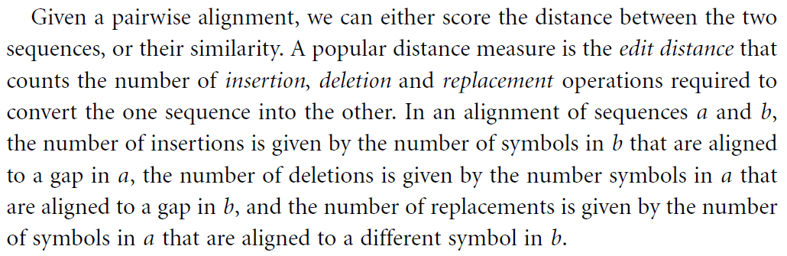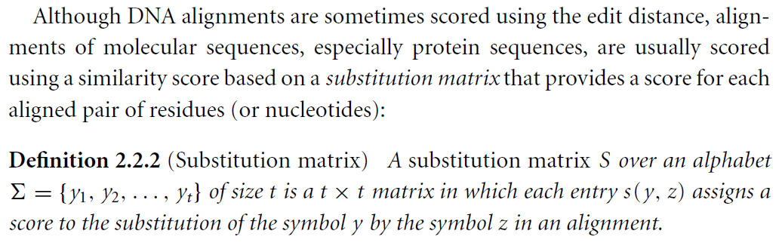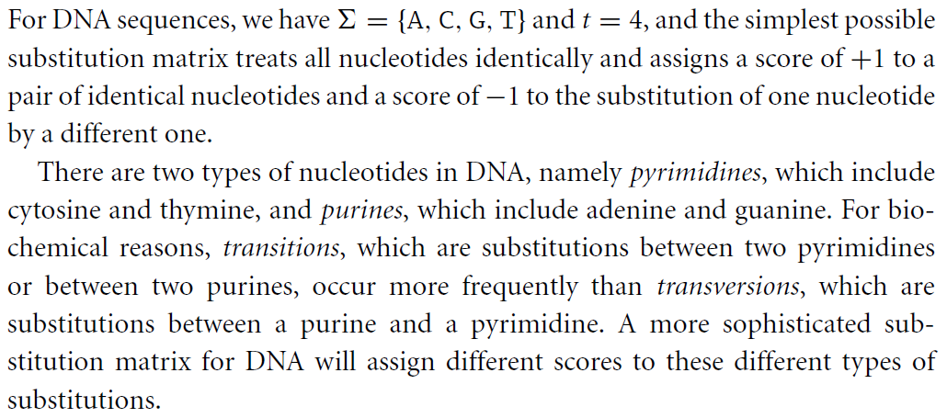

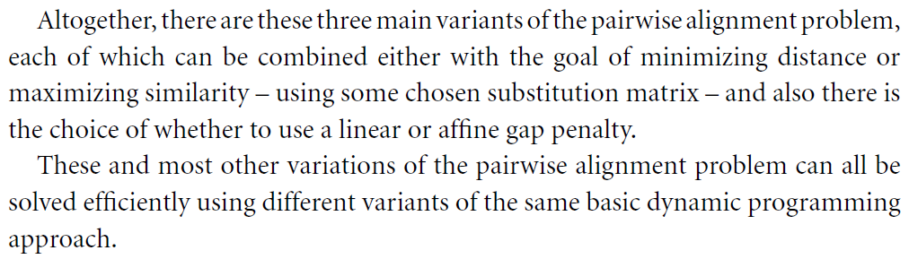

 

**Multiple sequence alignment**

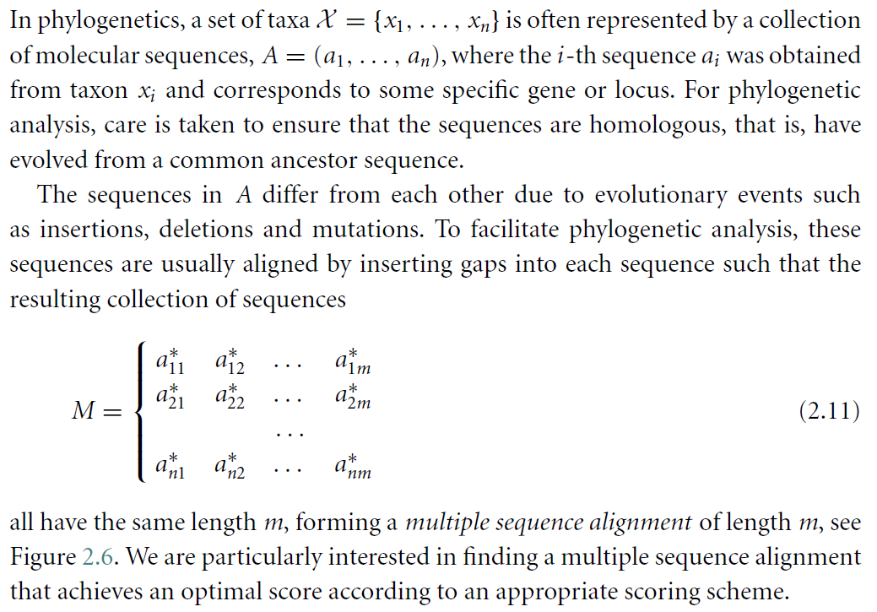

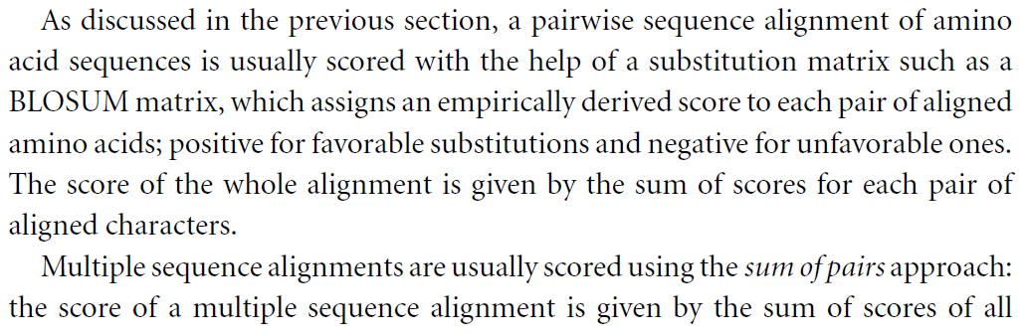

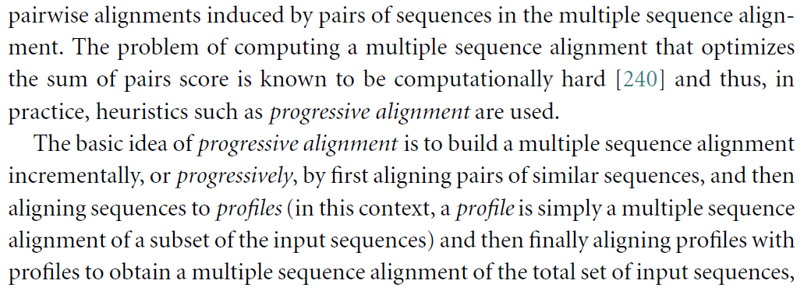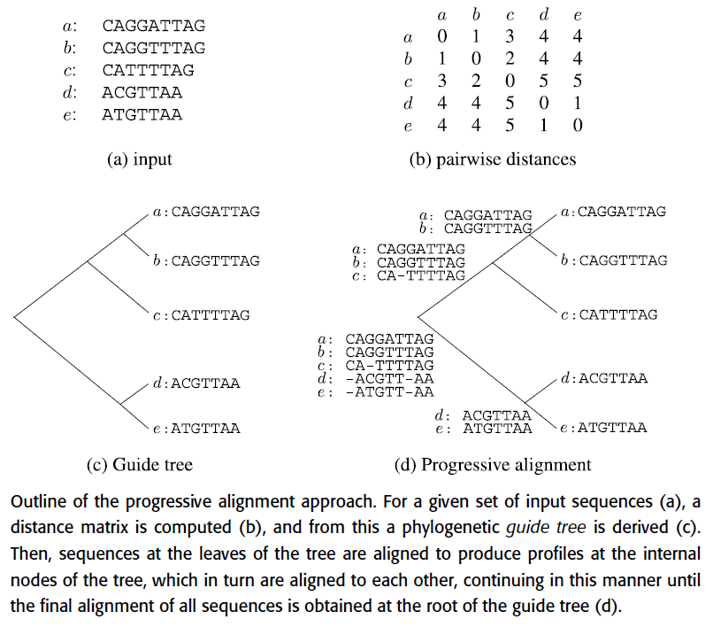

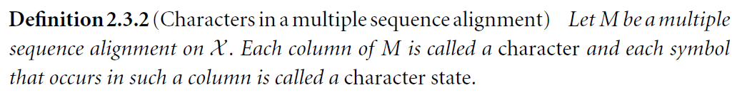

**Phylogenetic trees**

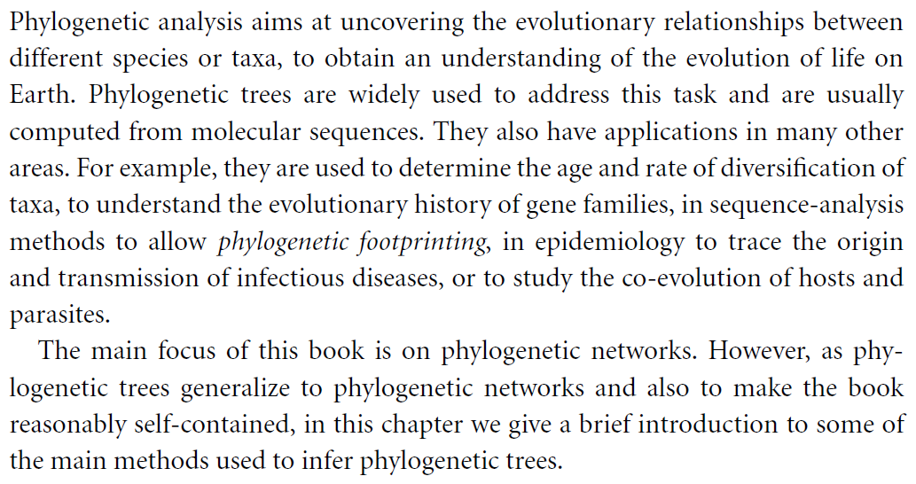

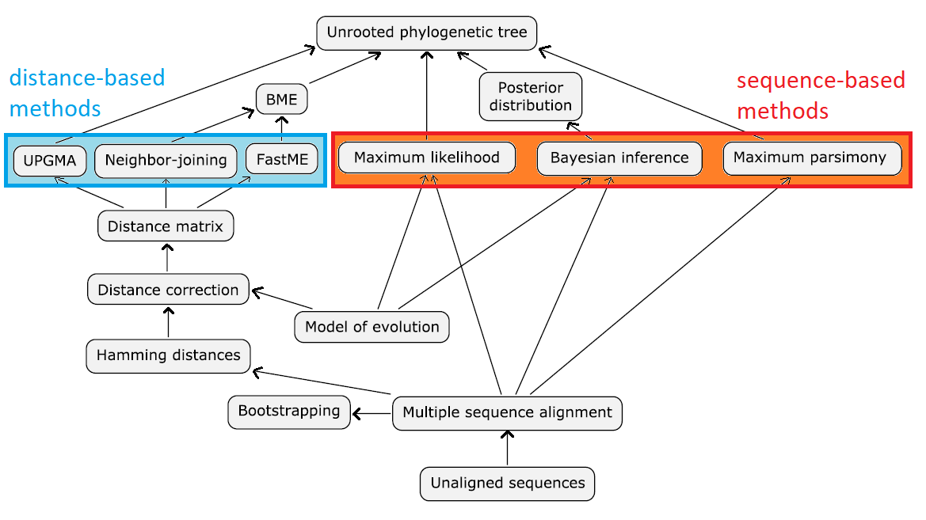

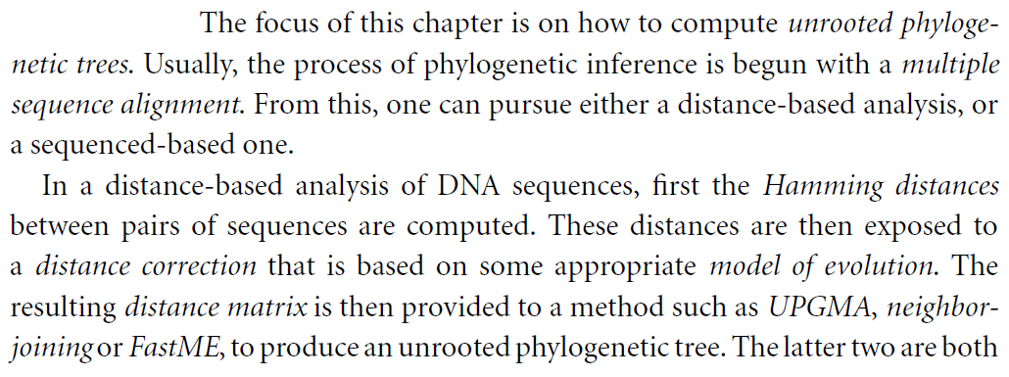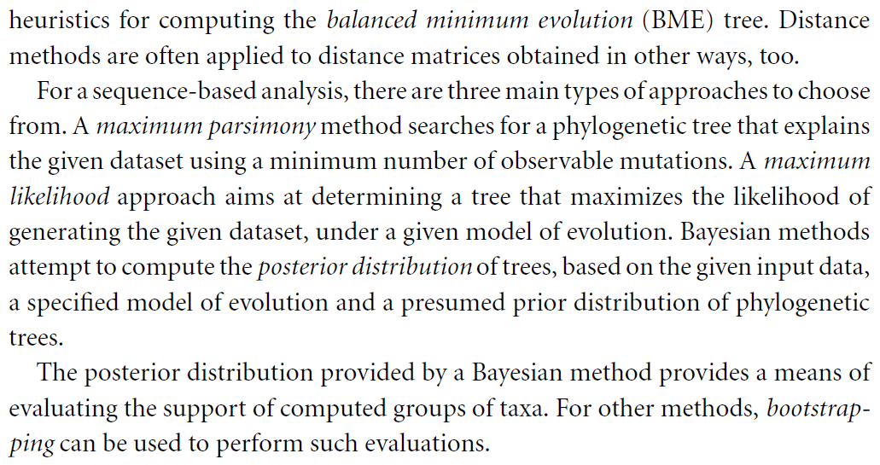

**Phylogenetic trees**

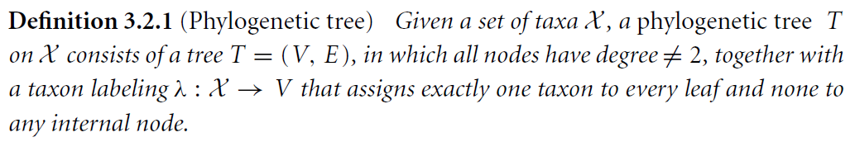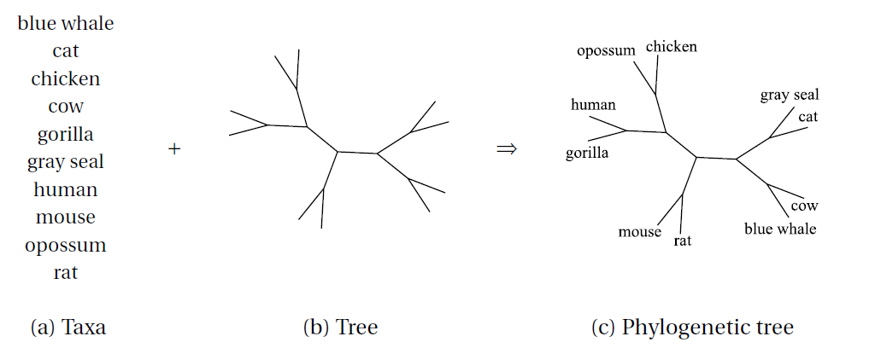

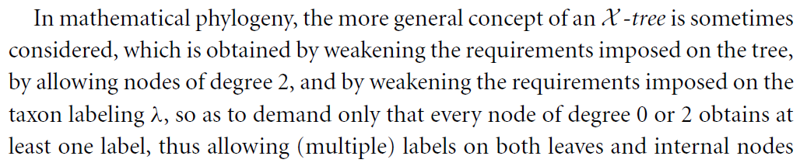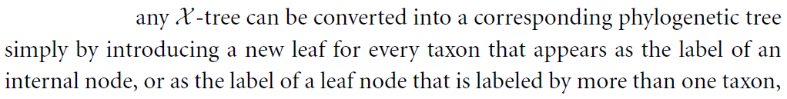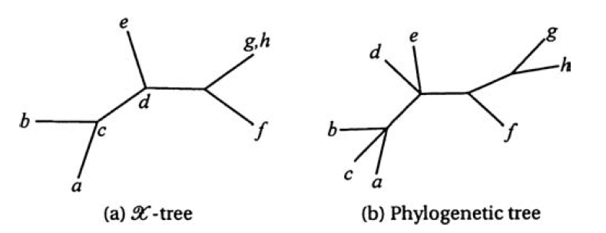

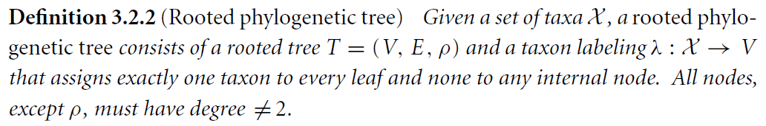

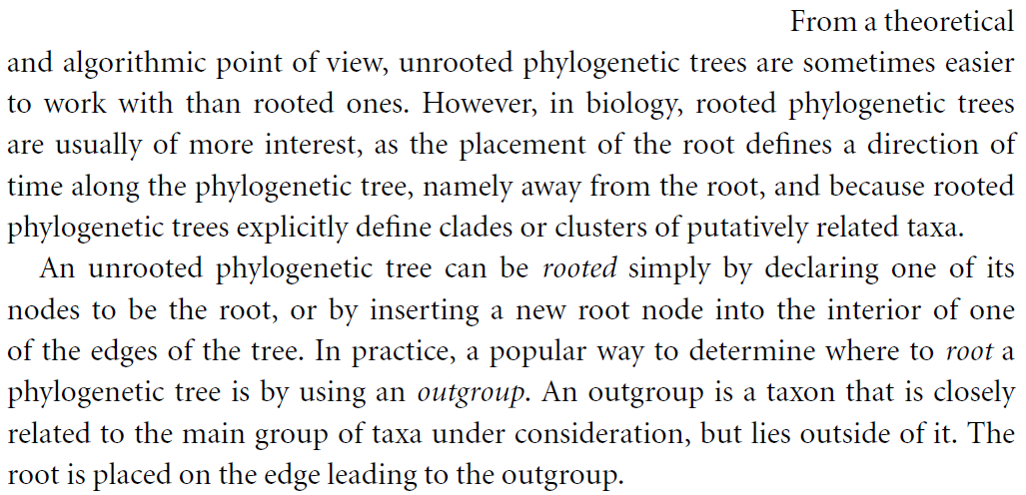

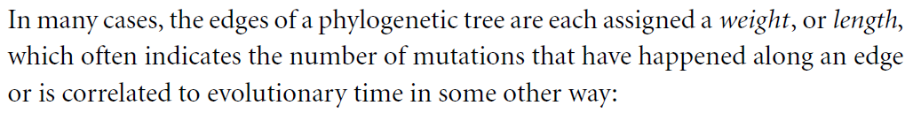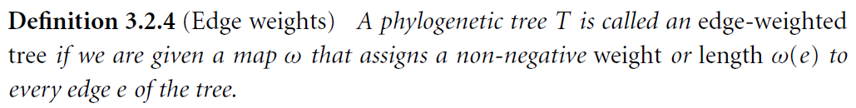

**The number of phylogenetic trees**

Let $V\left(n\right)$ and $E\left(n\right)$ be respectively the number of nodes and edges of a bifurcating (unrooted) phylogenetic tree on $n$ taxa.   
Notice that these numbers are well defined, since they do not depend on the exact topology of the tree.

We can obtain a tree on $n+1$ taxa by “grafting” (*innestare*) a new taxon onto a tree on $n$ taxa.

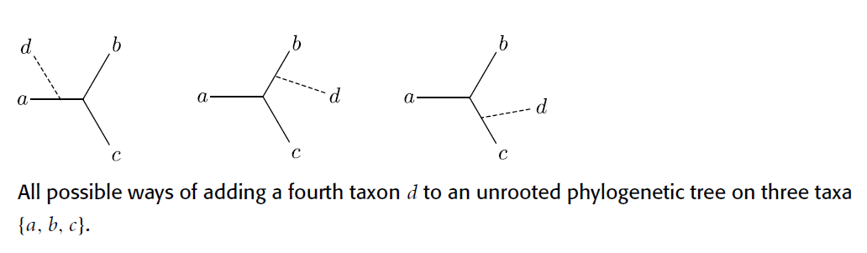

Observe that by adding a taxon, the number of nodes increases by 2 (the node corresponding to the new taxa plus the node of the intersection) and also the number of edges increases by 2 (the new edge connecting the node of the new taxa plus the “grafted” edge that gets splitted in two edges).

Therefore, these numbers can be characterized by the following relations

$$\left\{ \begin{matrix}V\left(n+1\right)=V\left(n\right)+2 \\ V\left(2\right)=2\end{matrix}\right. , \left\{ \begin{matrix}E\left(n+1\right)=E\left(n\right)+2 \\ E\left(2\right)=1\end{matrix}\right.$$

hence, by induction

$$V\left(n\right)=2n-2 , E\left(n\right)=2n-3$$

For the number of bifurcating trees $Tree(n)$ we have

$$\left\{ \begin{matrix}Tree\left(n+1\right)=Tree\left(n\right)⋅E\left(n\right) \\ Tree\left(2\right)=1\end{matrix}\right.$$

and again by induction

$$Tree\left(n\right)=1⋅3⋅5⋅…⋅\left(2n-5\right) \\ =\left(2n-5\right)‼$$

Rooted trees can be obtained by unrooted trees by inserting a node (the root) in the middle of an edge. Thus

$$V_{R}\left(n\right)=V_{U}\left(n\right)+1=2n-1$$

$$E_{R}\left(n\right)=E_{U}\left(n\right)+1=2n-2$$

$$Tree_{R}\left(n\right)=Tree_{U}\left(n+1\right)=\left(2n-3\right)‼$$

**Models of DNA evolution**

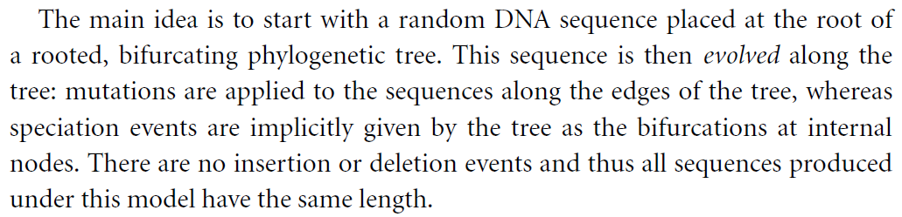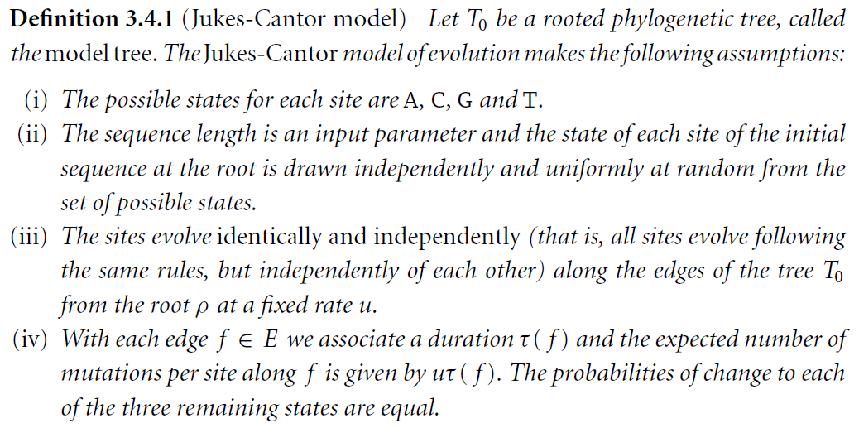

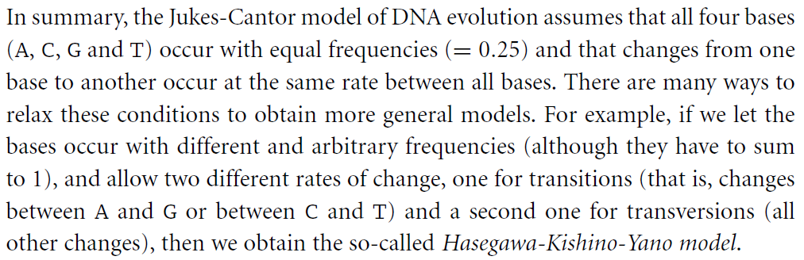

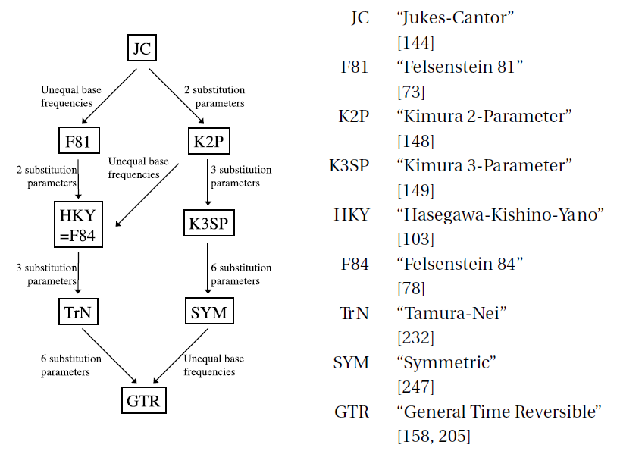

**The phylogenetic tree reconstruction problem**

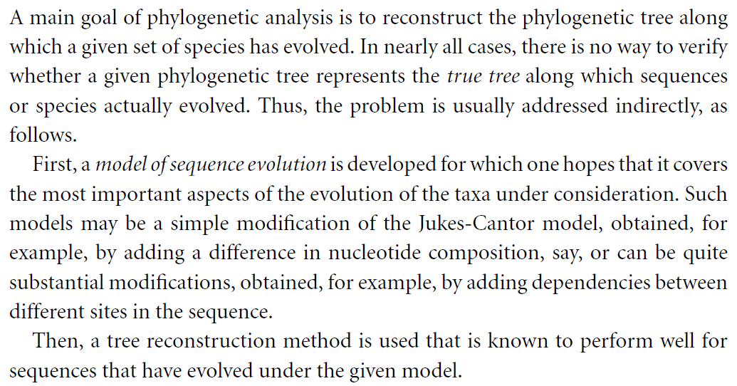

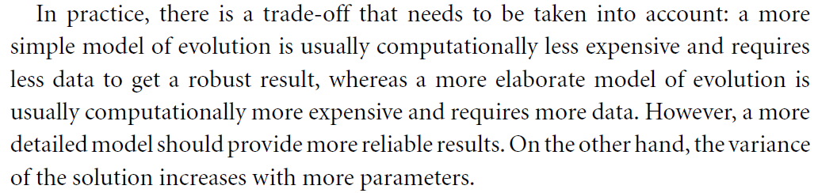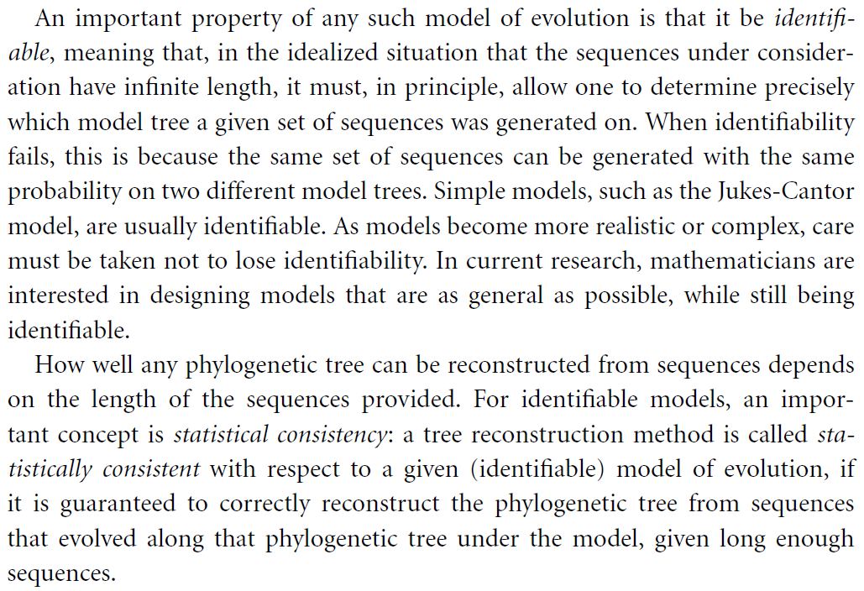

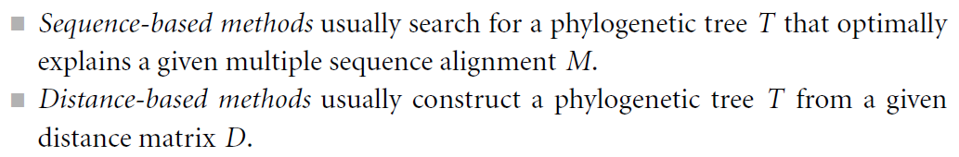

**Sequence-based methods**

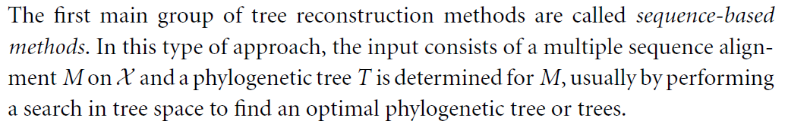

**Maximum parsimony**

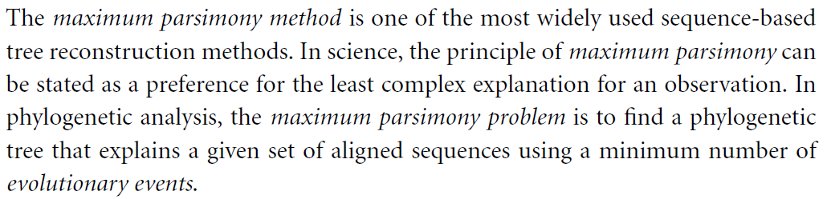 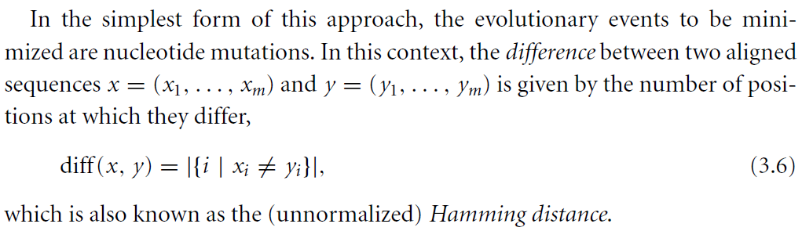

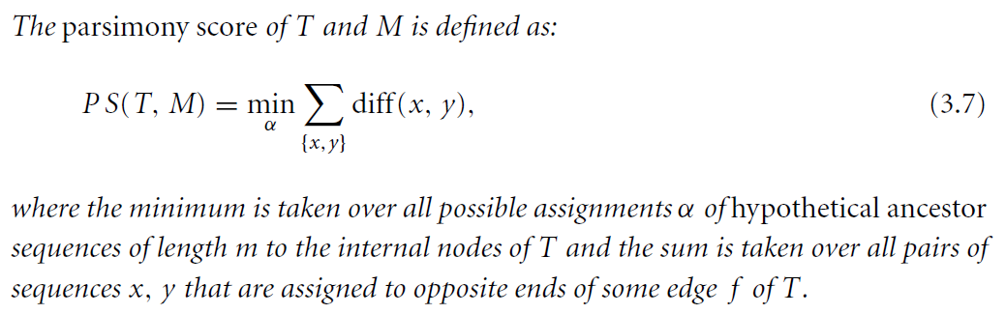

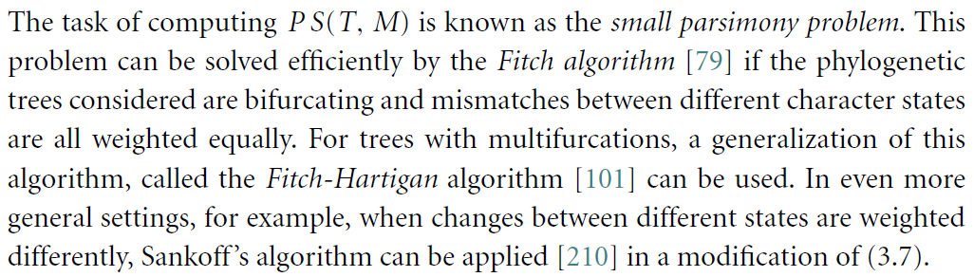 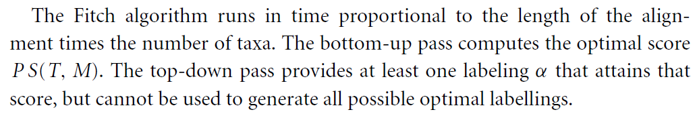

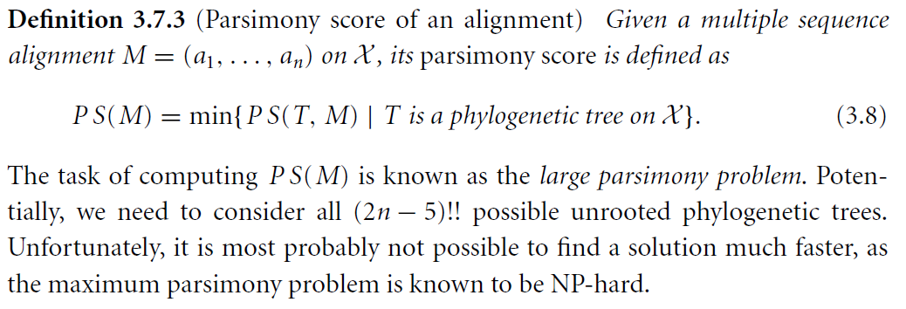

**Maximum likelihood estimation**

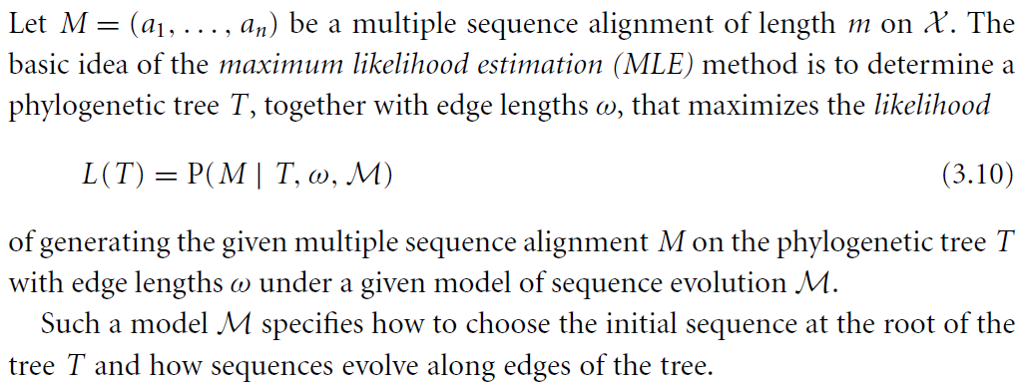

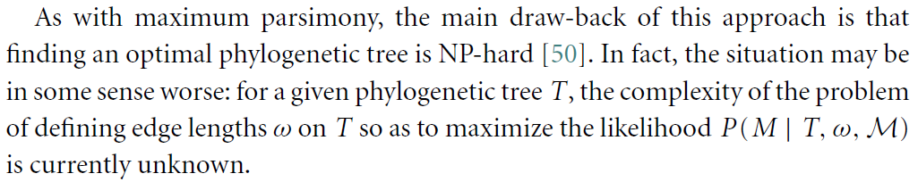



**Bootstrap analysis**

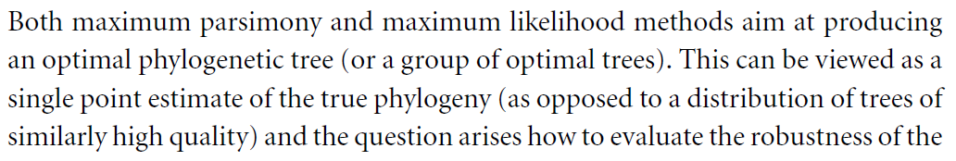 

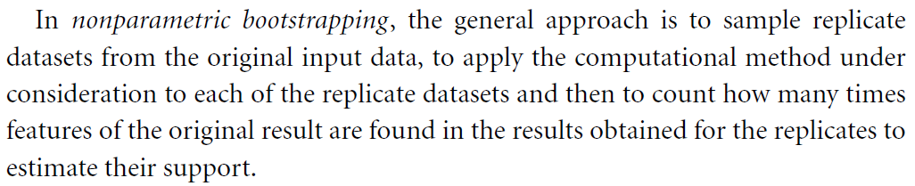

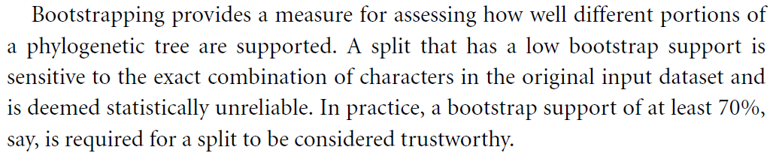

**Bayesian methods**

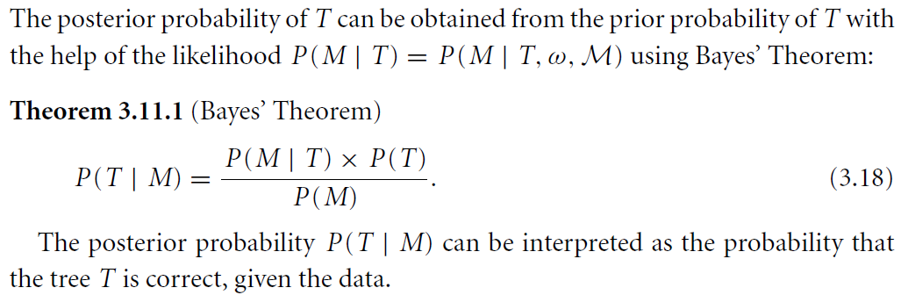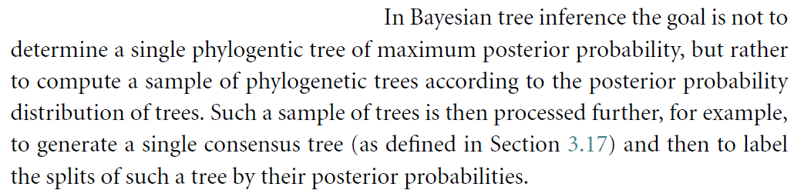

It is usually impossible to solve analytically the complete expression of the posterior probability.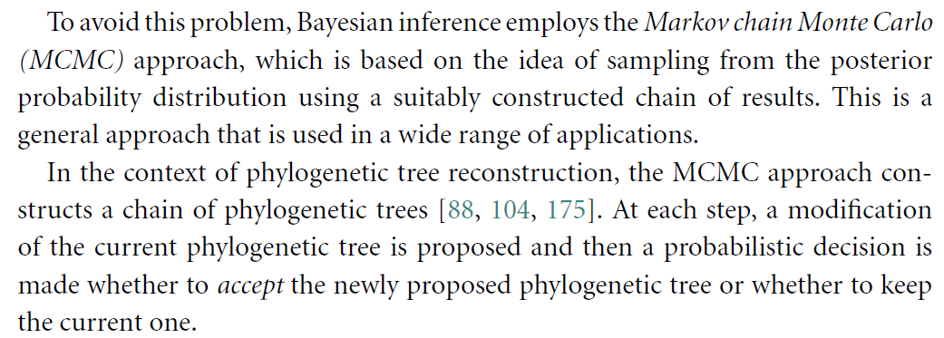

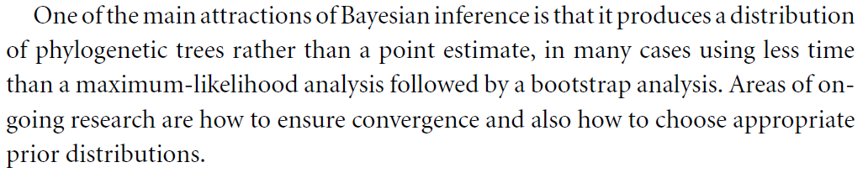

**Distance-based methods**

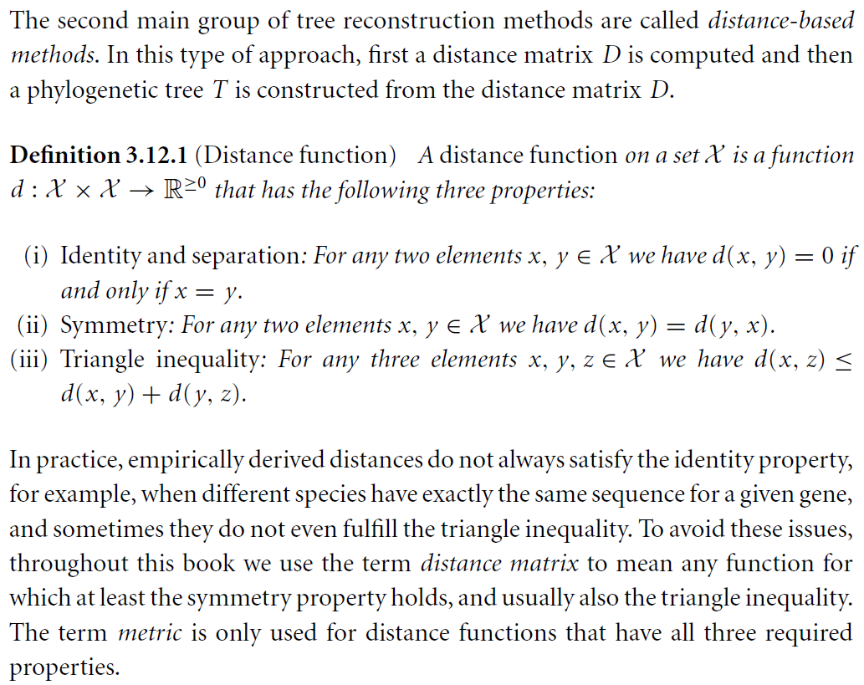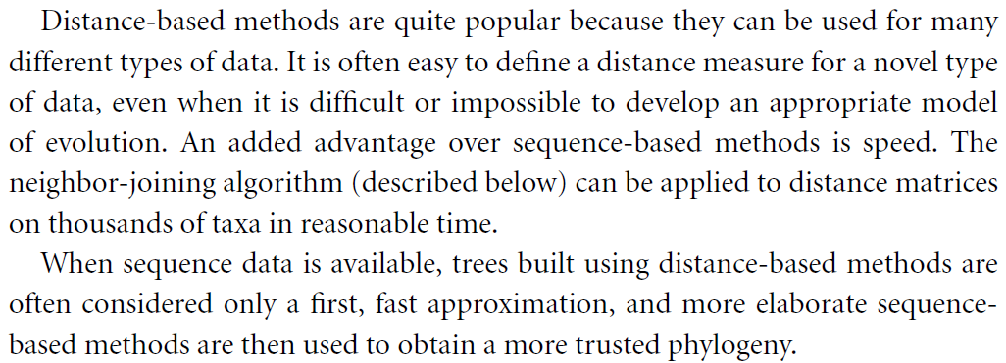

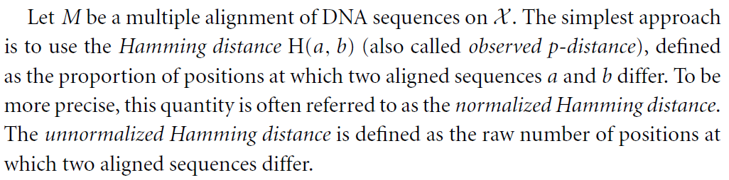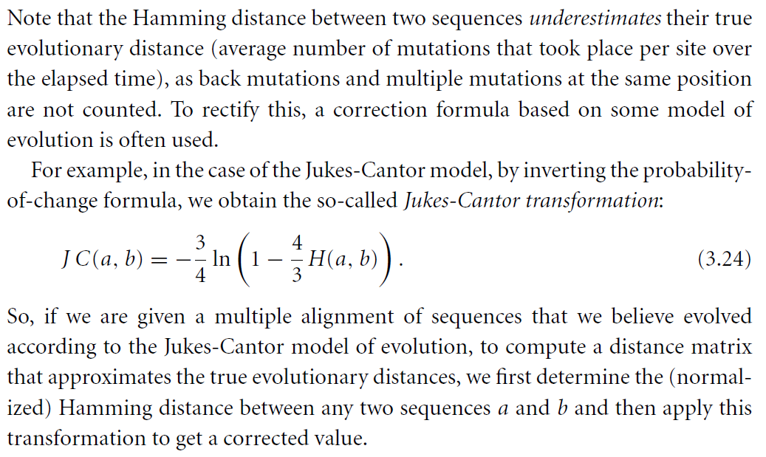

Let $T$ be a phylogenetic tree on $X$ with edge lengths $ω$.

The **tree distance $D_{T}(a,b)$** between any two taxa $a,b∈X$ is the sum of lengths $ω(e)$ of all edges $e$ on the unique path from the leaf labeled $a$ to the leaf labeled $b$.

The **tree length** of $T$ is the sum of lengths over all edges in $T$.

Let $D$ be a distance matrix on $X$.

We say that $D$ is an **additive distance** (or **tree-like**)  
 if there exists a phylogenetic tree $T$ such that $D=D_{T}$.

We say that $D$ satisfies the **four-point condition** if for every $w,x,y,z∈X$

$$wx+yz≤\max\left\{wy+xz,wz+xy\right\}$$

**Fact $D$** is additive if and only if it satisfies the four-point condition.

We say that $D$ satisfies the **three-point condition** if for every $x,y,z∈X$

$$xy=yz=xz or ij<ik=jk, \left\{i,j,k\right\}=\{x,y,z\}$$

or, equivalently, the **strong triangle inequality** if for every $x,y,z∈X$

$$xz≤\max\left\{xy,yz\right\}$$

**Dim**. $(⇒)$ Let $x,y,z∈X$. Then if $xy=yz=xz$, we are done.

Suppose $xz<xy=yz$. Then it is clear that

$$xz≤\max\left\{xy,yz\right\} \\ xy≤yz=\max\left\{yz,xz\right\} \\ yz≤xy=\max\left\{xy,xz\right\}$$

$(⇐)$ Let $x,y,z∈X$. By hypothesis we know that

$$xz≤\max\left\{xy,yz\right\} \\ xy≤\max\left\{xz,yz\right\} \\ yz≤\max\left\{xy,xz\right\}$$

It is clear that if one of the previous inequalities holds as equal, then there must be another one that holds as equal as well.  
Therefore, the third can also holds as equal or as strictly less.

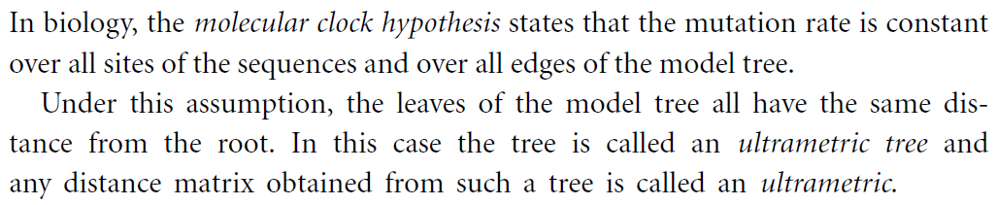

**Fact $D$** is an ultrametric if and only if it satisfies the three-point condition (or equivalently the strong triangle inequality).

**UPGMA and Neighbor-Joining**

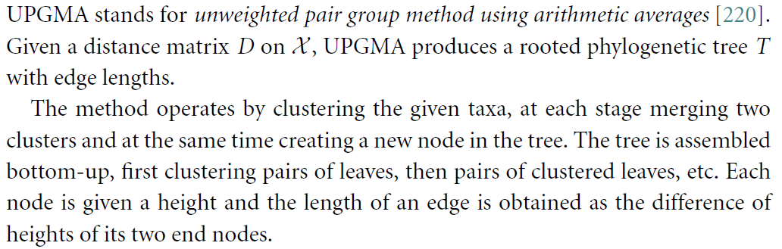 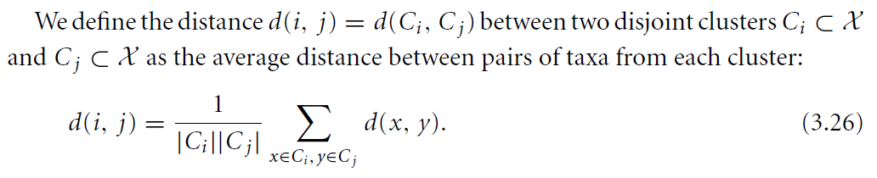



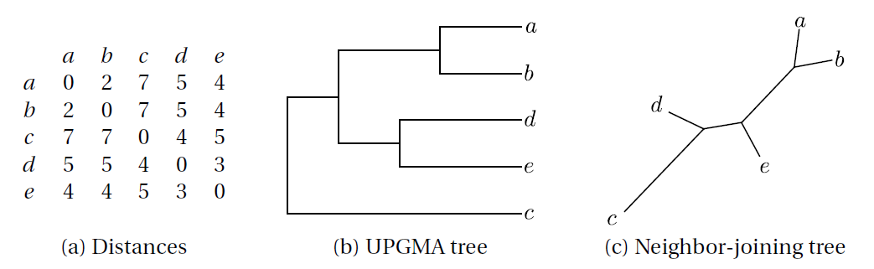

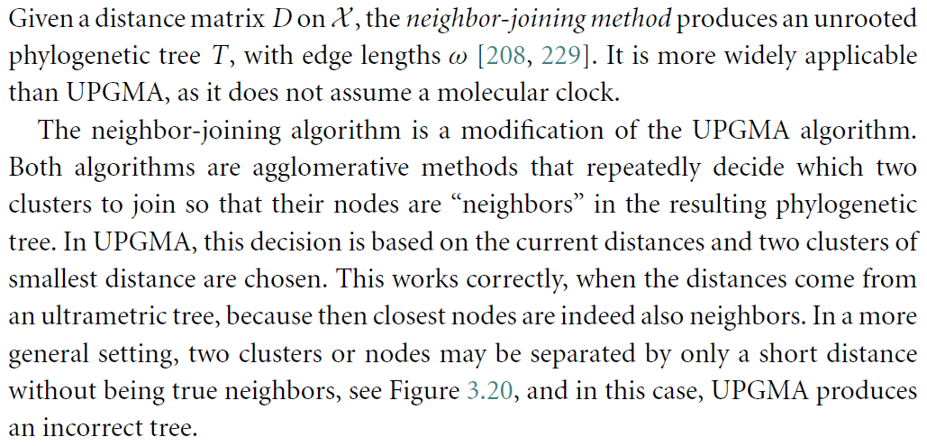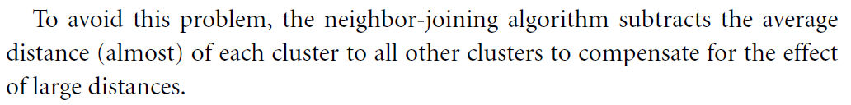 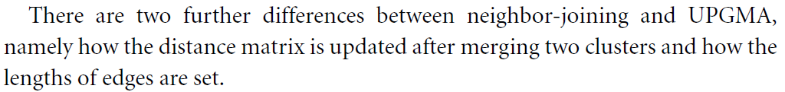

**Facts** Let $D$ be a distance matric on $X$.

Then UPGMA computes a (rooted) tree $T$ such that $D_{T}=D$  
 if and only if $D$ is ultrametric.

And NJ computes an (unrooted) tree $T$ such that $D_{T}=D$  
 if and only if $D$ is additive.

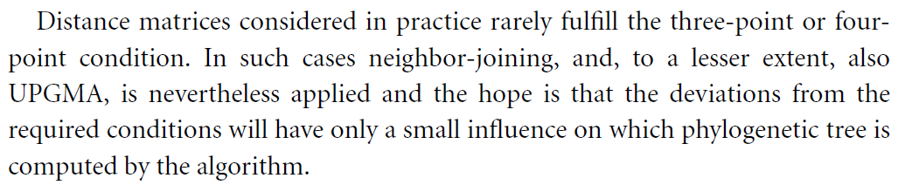

**Balanced minimum evolution**

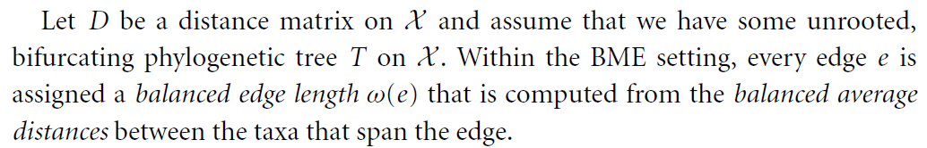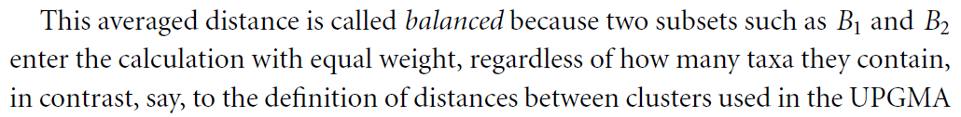

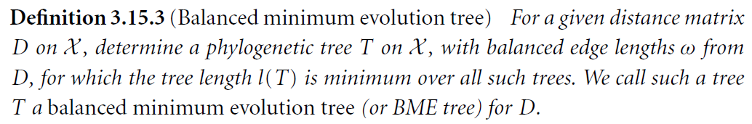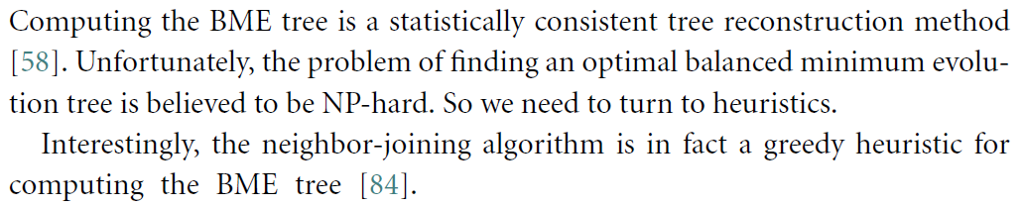

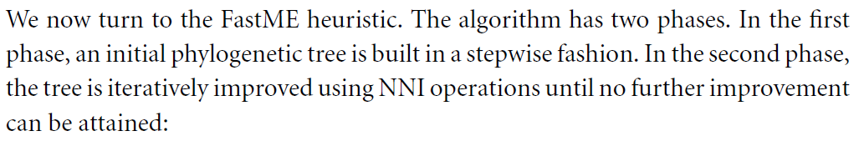

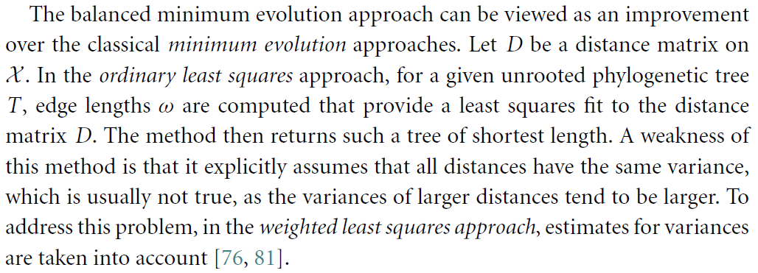

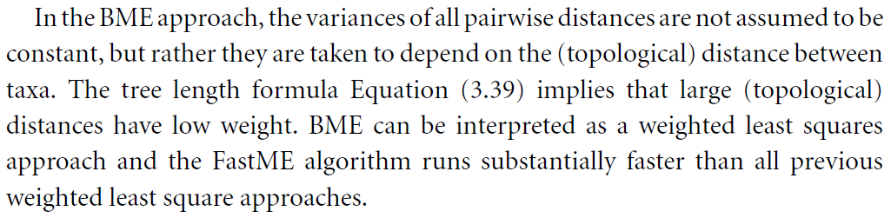

**The least squares method**

from [Felsenstein2004]

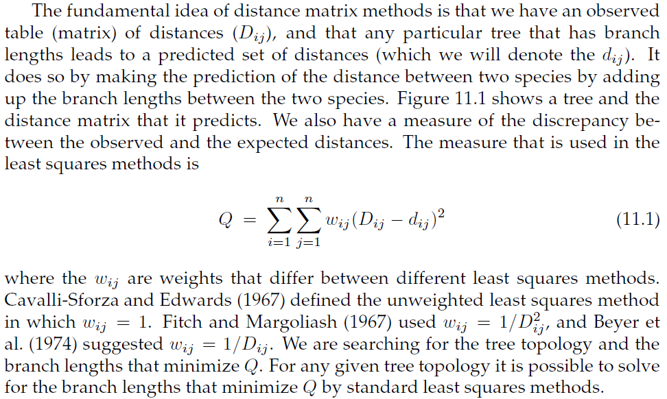

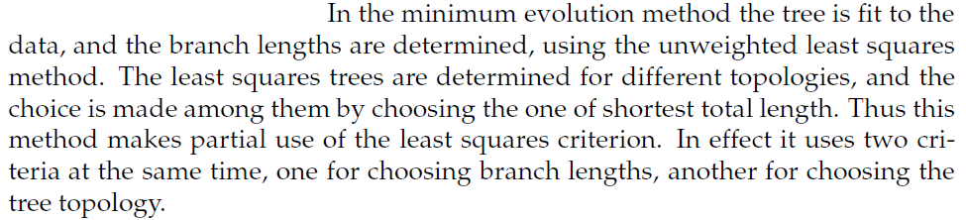

**Phylogenetic networks**

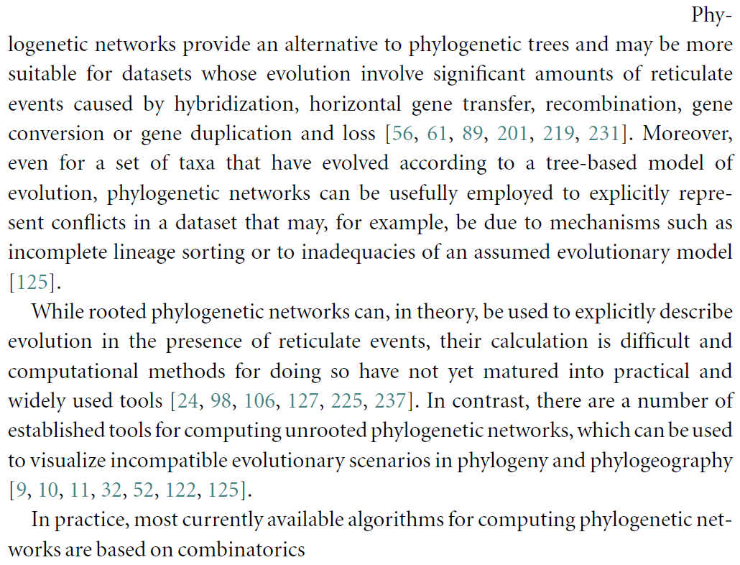

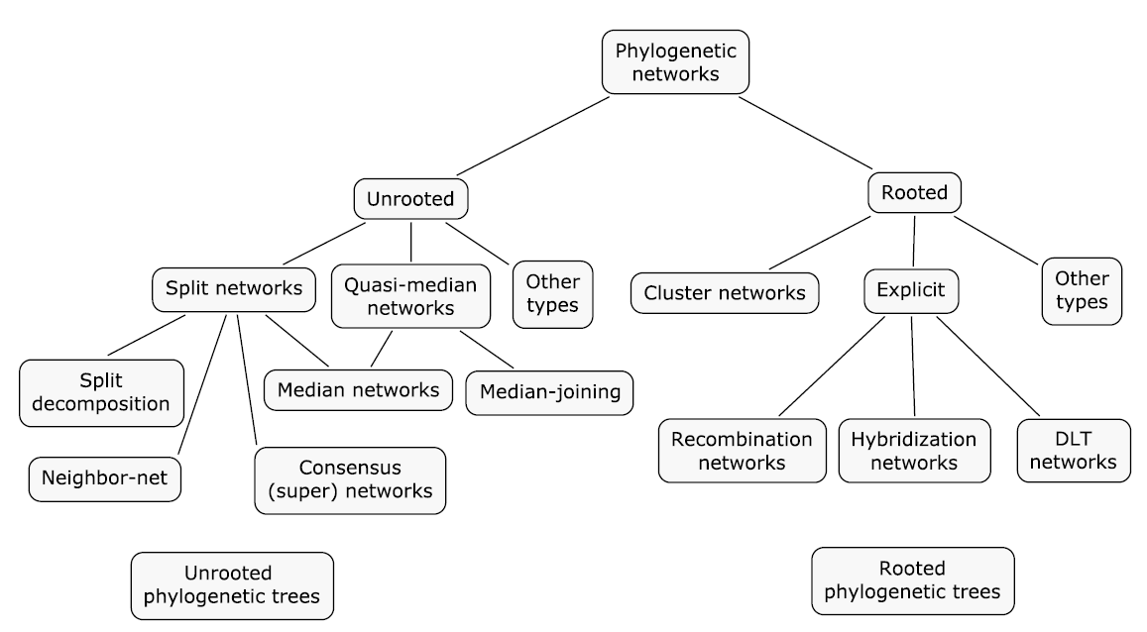

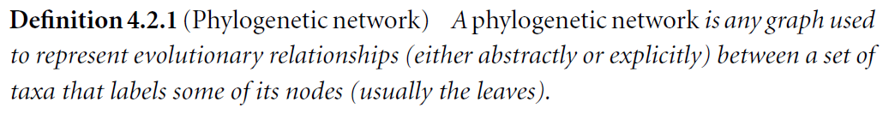

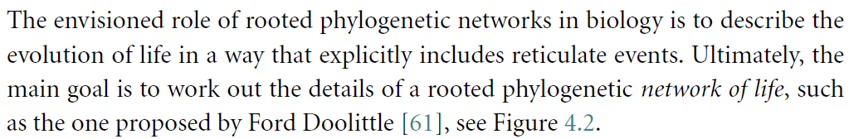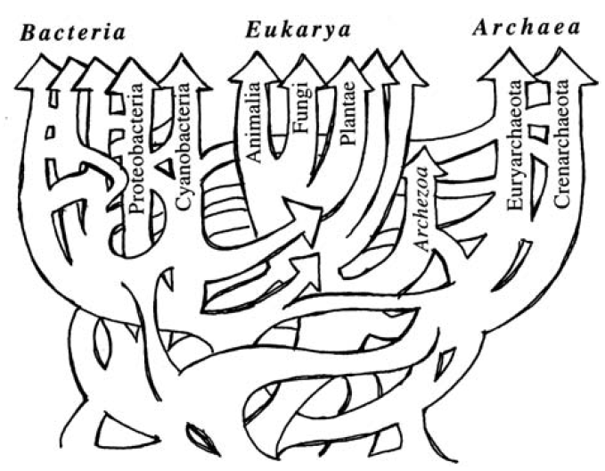

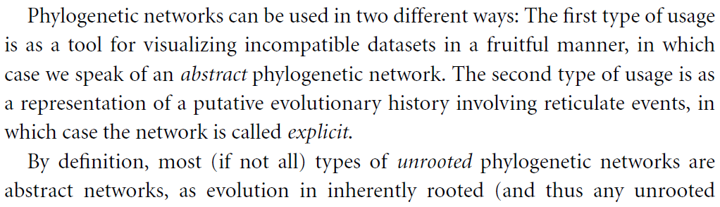 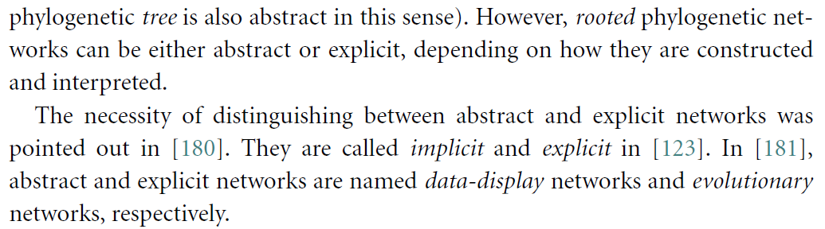

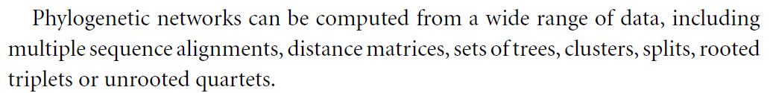

Unrooted phylogenetic networks

* split networks
  + from distances
    - split decomposition
    - **neighbor-net**
  + from trees
    - **consensus (super)  
       split networks**
  + from sequences
    - median networks
  + from quartets
    - quartet-net
* quasi-median networks
  + median networks
  + **median joining**
* others
  + haplotype networks
  + reticulograms

Rooted phylogenetic networks

* from clusters
  + hardwired
    - cluster networks
  + softwired
    - galled trees
    - level-k networks
    - galled networks
* explicit networks
  + hybridization networks
  + recombination networks
  + DLT networks
* others
  + reassortment networks
  + networks from  
     multi-labeled trees
  + networks from  
     rooted triples

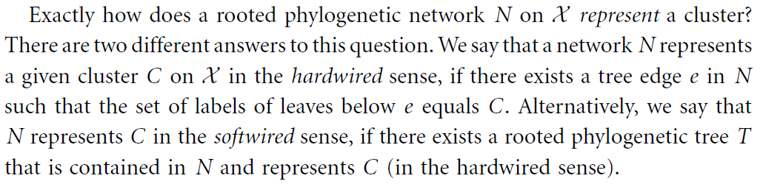

**Networks used in practice**

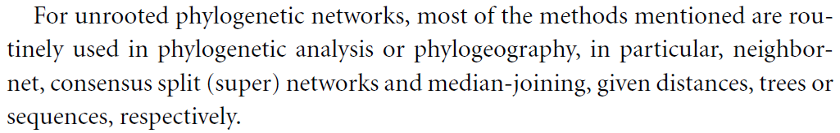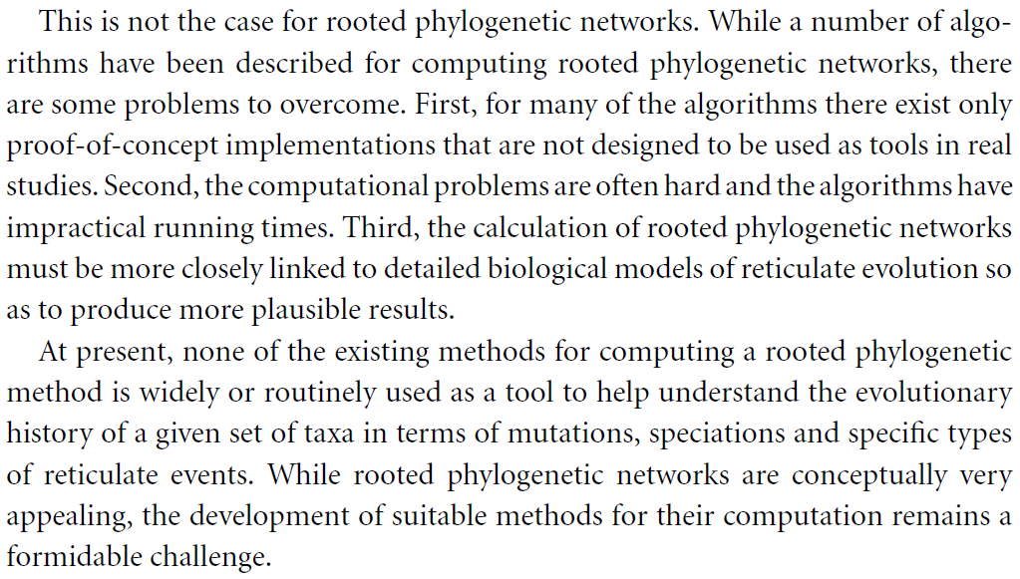

**Split networks**

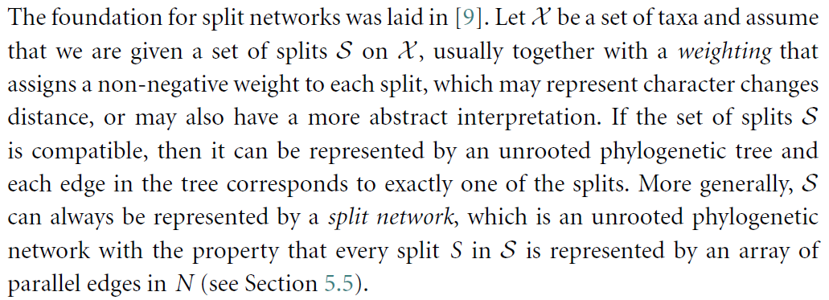

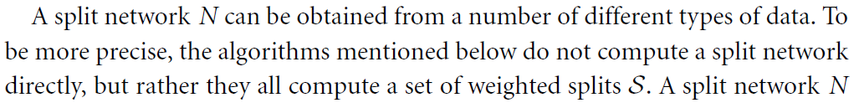

**Split networks from distances**

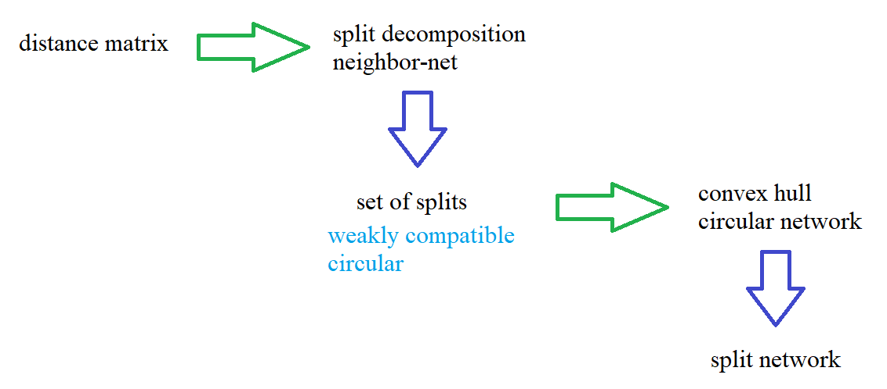

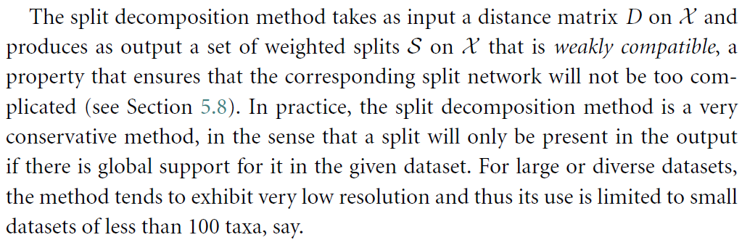

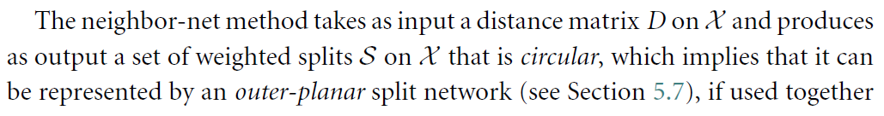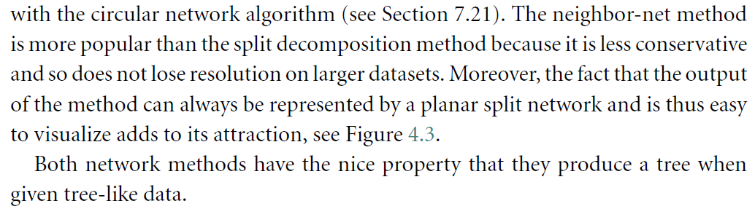

**Splits and unrooted phylogenetic networks**

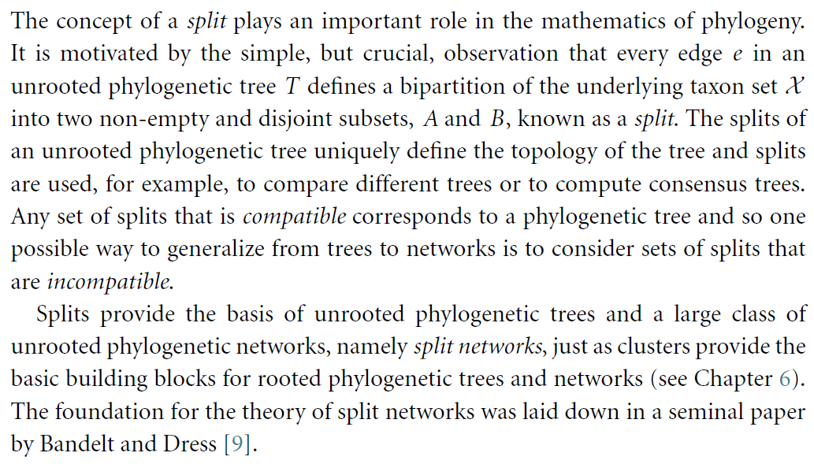

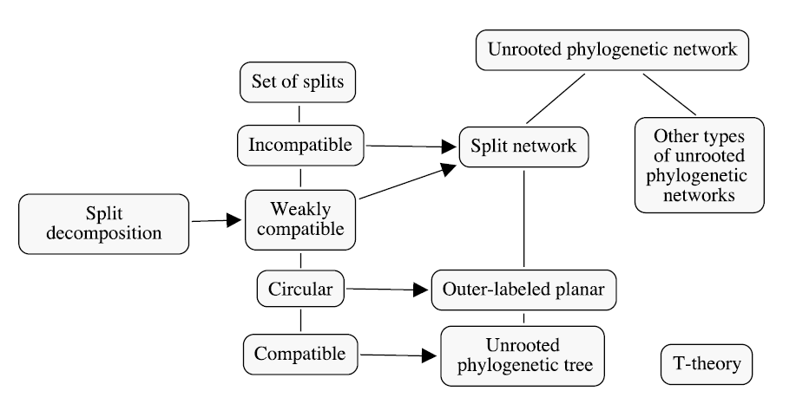

**Splits**



A **split** is a partition of $X$ into two non-empty subsets $A,B⊆X$  
 such that $A∩B=∅$ and $A∪B=X$.

A **weighted split** is a split $S$ that has been assigned a weight $ω\left(S\right)≥0$.

We use the notations: $A | B$ or $\frac{A}{B}$.  
Notice that there is no ordering in a split, so $A | B=B | A$.  
We call $A$ and $B$ the **parts** of the split.

The **size** of a split $S=A | B$ is the minimal cardinality of its parts

$$size\left(S\right)≔\min{\{\left|A\right|,\left|B\right|\}}$$

A **trivial split** is a split of size one.

For any taxon $x∈X$ , we denote with $S(x)$ the split part that contains $x$ and with $\overline{S}(x)$ the other part.

Let $S$ be a set of splits and $X^{'}⊂X$ a subset of taxa.  
The set of **splits induced** by $X^{'}$ or **restriction** of $S$ to $X^{'}$ is the set

$$S{\left.​\right|}_{X^{'}}≔\left\{ \frac{A∩X^{'}}{B∩X^{'}} : \frac{A}{B}∈S, \begin{matrix}A∩X^{'}≠∅ , \\ B∩X^{'}≠∅ \end{matrix} \right\}$$

that is the splits restricted such that they remain splits.

Any edge $e$ of a phylogenetic tree $T$ defines a split of the underlying taxon set $X$: deleting $e$ produces two subtrees, and their taxon labels form the parts of the split.   
In fact, since every leaf in a phylogenetic tree is label by some taxon, the two parts are non-empty (the two subtrees must contains some leaves); and, since each taxon occurs precisely once, it follows that the two parts are disjoint and cover all the taxa.  
We denote with $σ_{T}(e)$ the split **represented** by the edge $e$.

If the edges of the tree have lengths/weights,  
 then these can be assigned to the corresponding split.

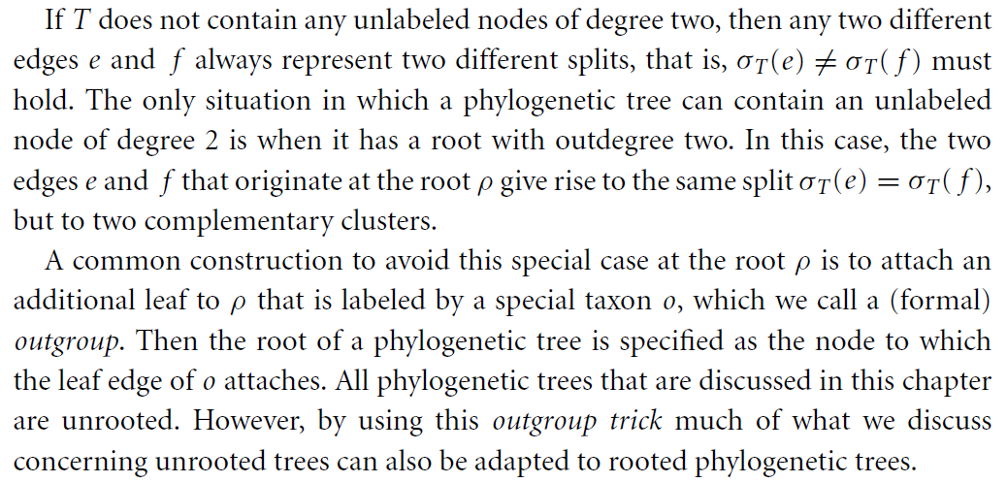

Let $T=(V,E)$ be an unrooted phylogenetic tree.

The **split encoding** of $T$ is the set of all splits represented by its edges

$$S\left(T\right)≔\left\{ σ_{T}\left(e\right) :e∈E \right\}$$

A tree can be uniquely reconstructed from its split encoding.

A tree $T$**represents** a set of splits $S$ if $S\left(T\right)=S$.

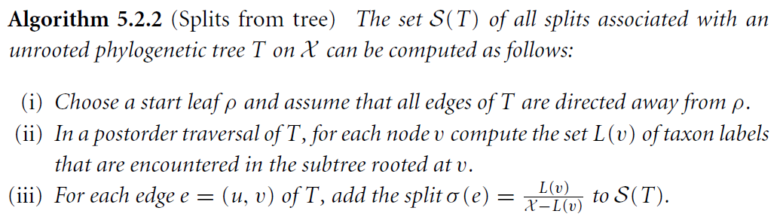

This algorithm is quadratic in time.

**Compatibility**

Two splits $S_{1}=A_{1} | B_{1}$ and $S_{2}=A_{2} | B_{2}$ are **compatible**  
 if one of the following intersections is empty

$$A_{1}∩A_{2} , A_{1}∩B_{2} , A_{2}∩B_{1} , B_{1}∩B_{2}$$

Two splits that are not compatible are **incompatible**.  
A set of splits is **compatible** if all the splits are (pairwise) compatible.

**Fact** Let $S$ be a set of splits on $X$ that contains all trivial splits on $X$.

There exists a unique unrooted phylogenetic tree $T$  
 that realizes $S$ if and only if $S$ is compatible.

We can drop the hypothesis on trivial splits if we consider $X$-trees.

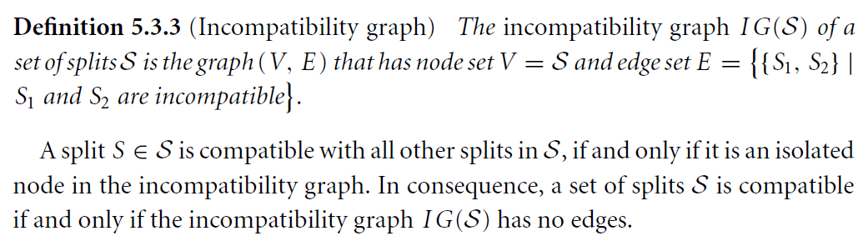

**Splits and clusters**

splits -> clusters

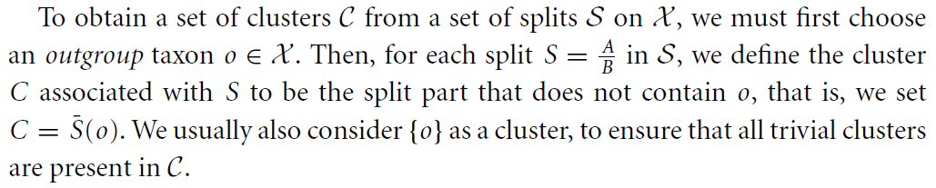

**Teo**. $S$ is compatible if and only if $C$ is compatible.

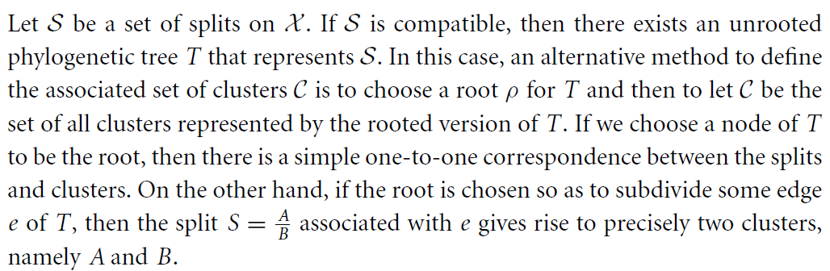

clusters -> splits

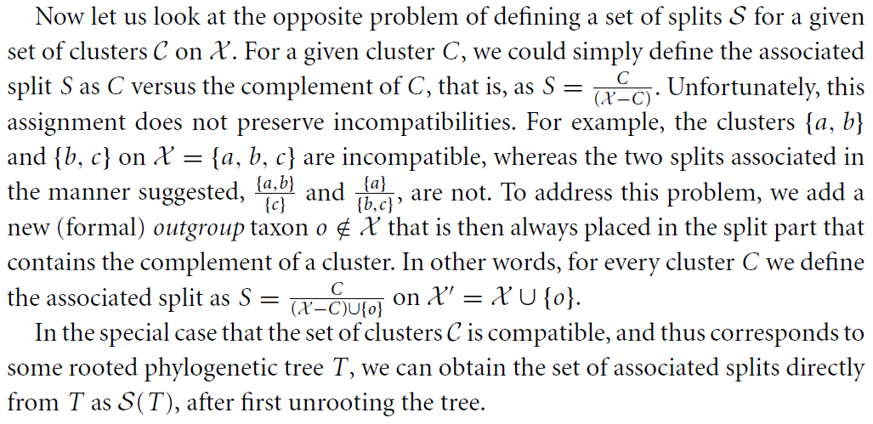

The number of all splits on a set of $n$ taxa is $2^{n-1}-1$  
 (the number of clusters is the same, off by one).

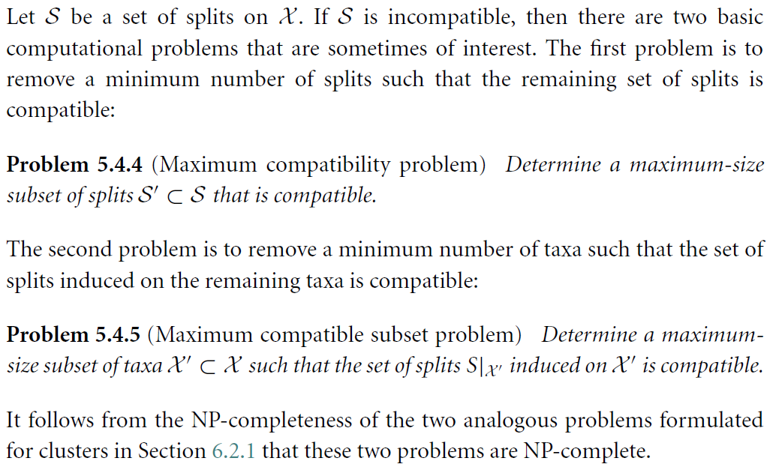

**Split networks**

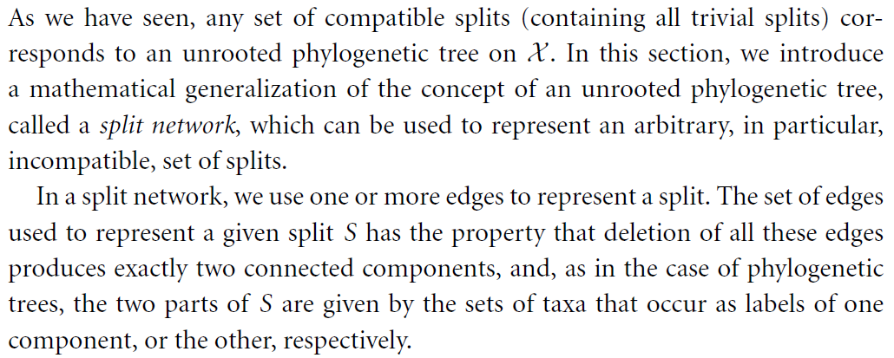

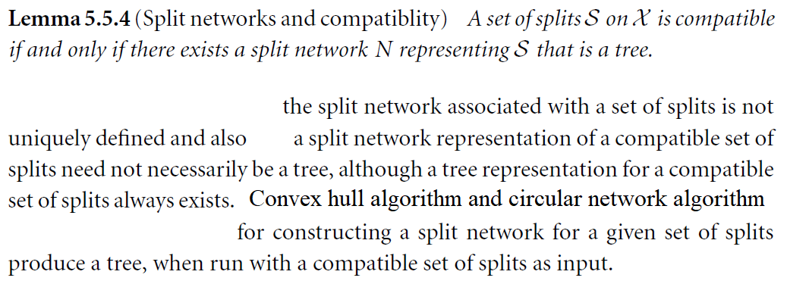

**Canonical split network**

For any set of splits $S$ there exists a unique split network that represents $S$, called the **canonical split network** or **Buneman graph** associated with $S$.

If $S$ is compatible, then the Buneman graph is an unrooted phylogenetic tree.

The number of nodes and edges of the Buneman graph is exponential in the number of splits, in the worst case.

The network computed by the convex hull algorithm is the Buneman graph.

**Circular splits**

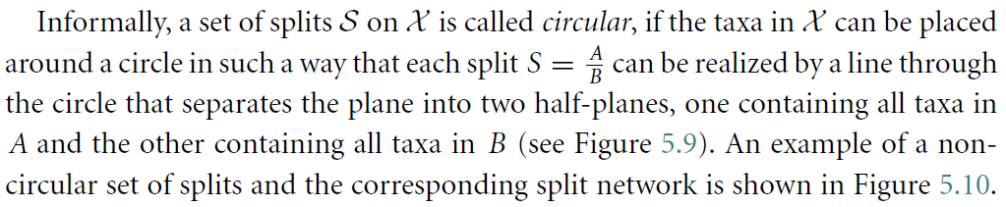 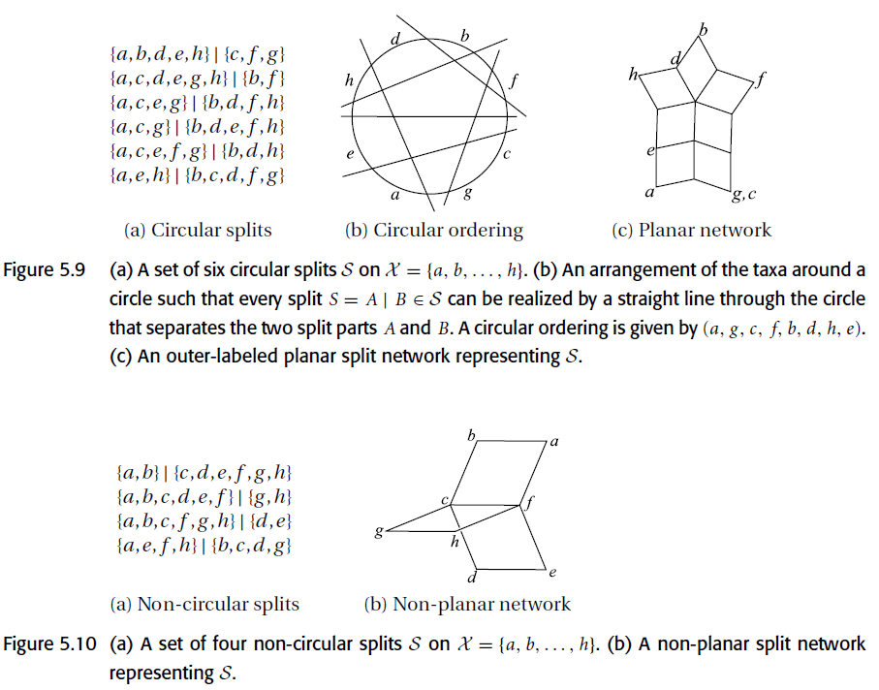

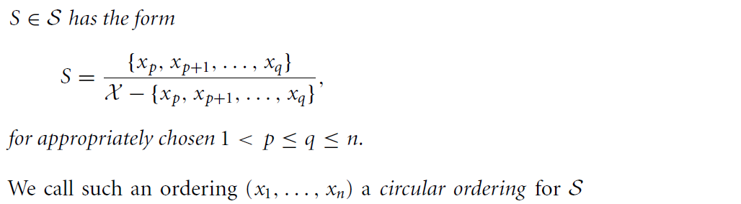

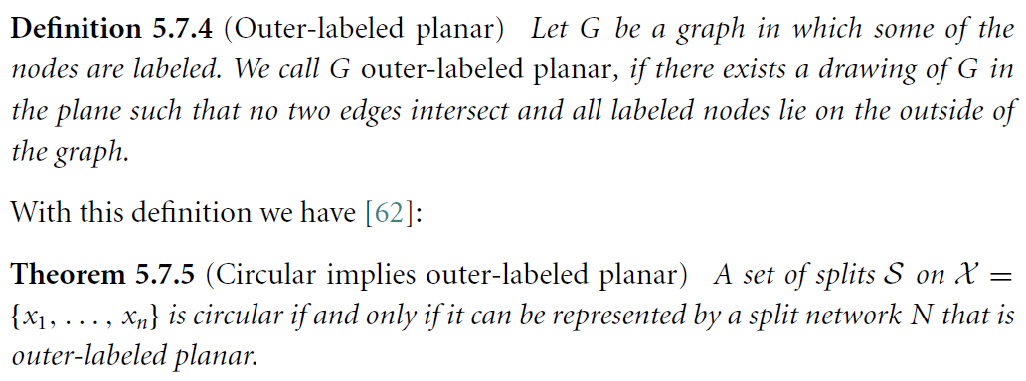

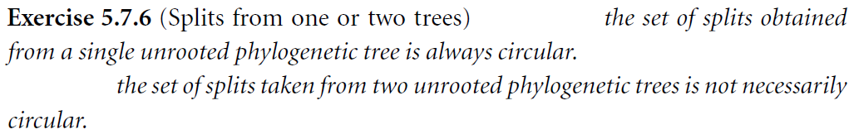

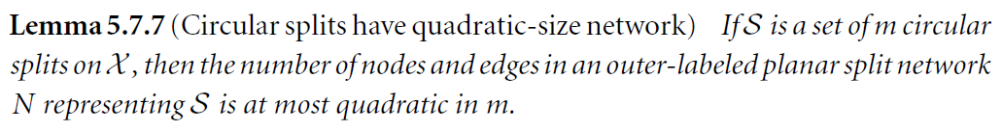



**Weak compatibility**

Three splits $S_{1}=\frac{A_{1}}{B_{1}}, S_{2}=\frac{A_{2}}{B_{2}}, S_{3}=\frac{A_{3}}{B_{3}}$ are **weakly compatible**  
if at least one of the following intersections is empty

$$A_{1}∩A_{2}∩A_{3} , A_{1}∩B_{2}∩B_{3} , B_{1}∩A_{2}∩B_{3} , B_{1}∩B_{2}∩A_{3}$$

and at least one of the following intersections is empty

$$B_{1}∩B_{2}∩B_{3} , B_{1}∩A_{2}∩A_{3} , A_{1}∩B_{2}∩A_{3} , A_{1}∩A_{2}∩B_{3}$$

A set of splits is weakly compatible if all its splits are (triplewise) weakly compatible.

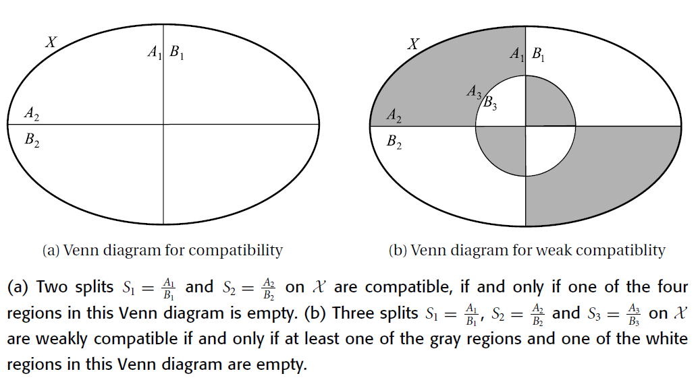

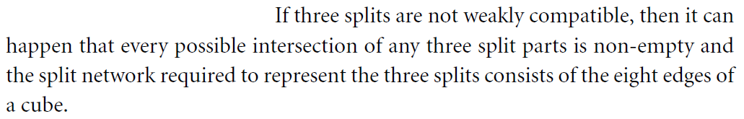

Thus the split networks associated with weakly compatible splits are often quite close to being planar, as they usually have only a few edges crossing over each other and do not contain any “high-dimensional cubes”, which may occur for completely unrestricted sets of splits.

The set of splits obtained by two unrooted phylogenetic trees is weakly compatible.



**Buneman tree**

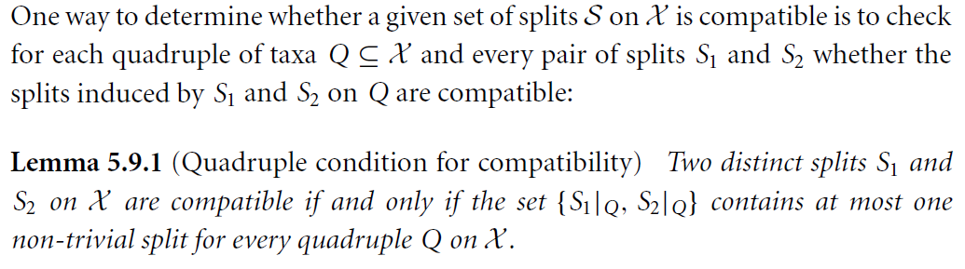 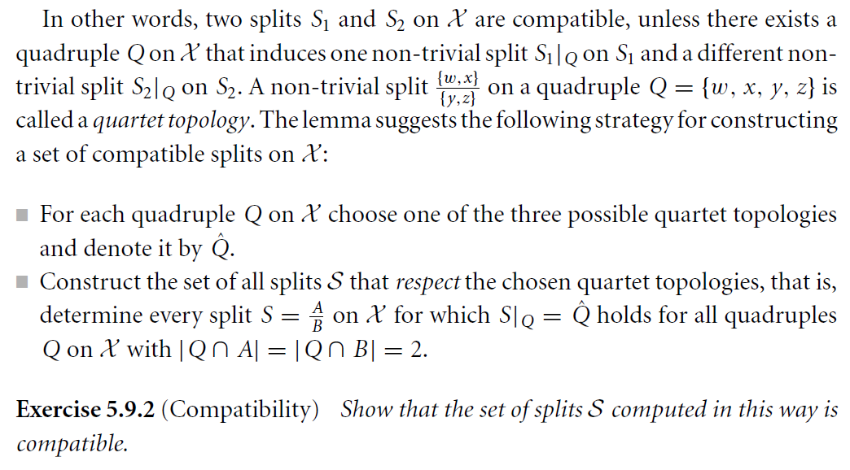

 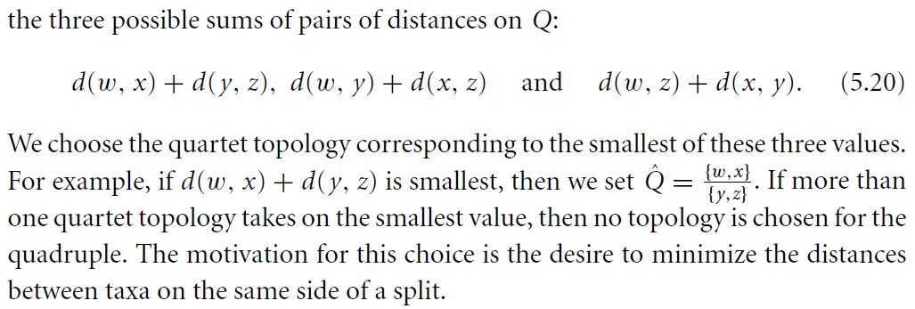

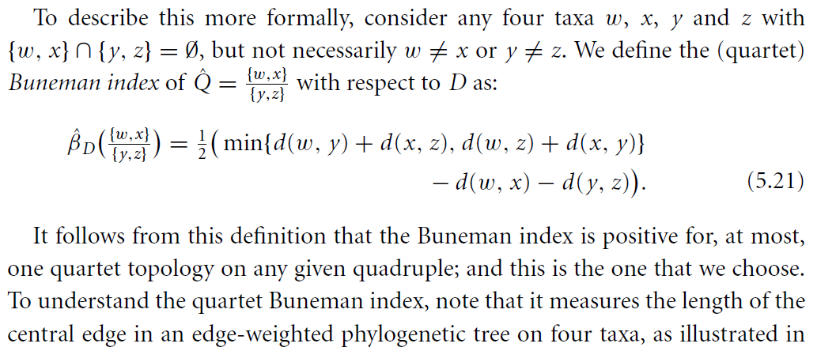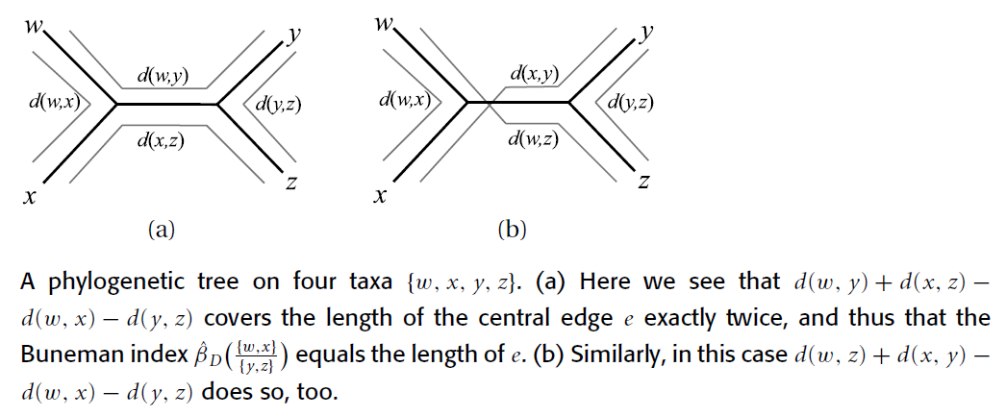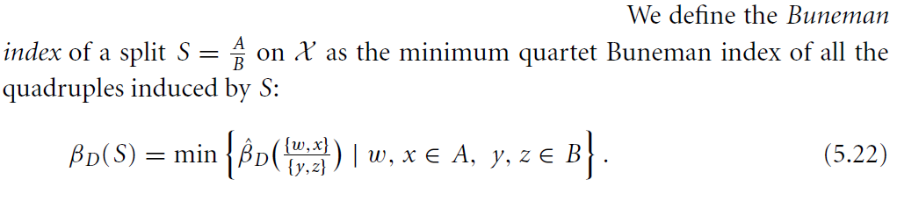

The set of splits with positive Buneman index is compatible and the corresponding unrooted phylogenetic tree is called the **Buneman tree** for $D$.

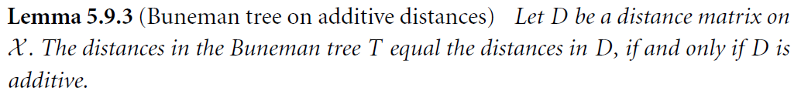

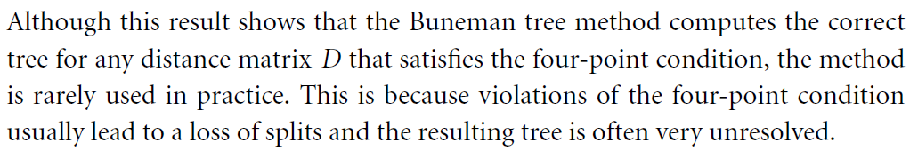

**Refined Buneman tree**

from [BM99], [MS99]

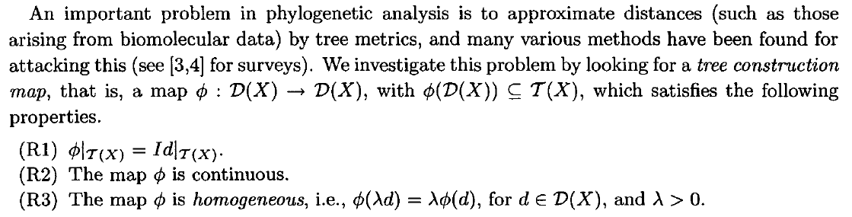 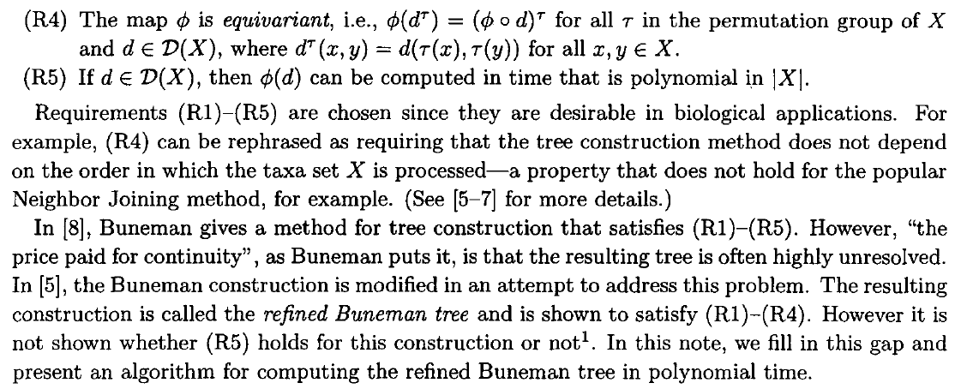

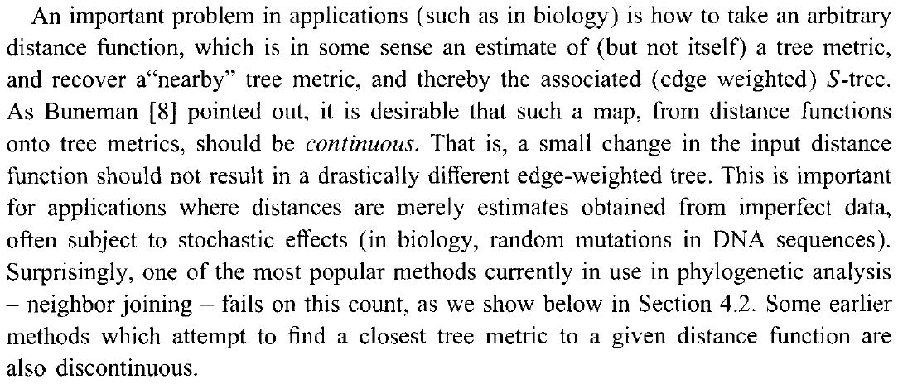 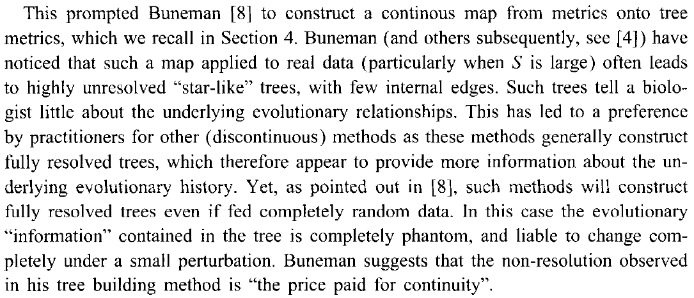 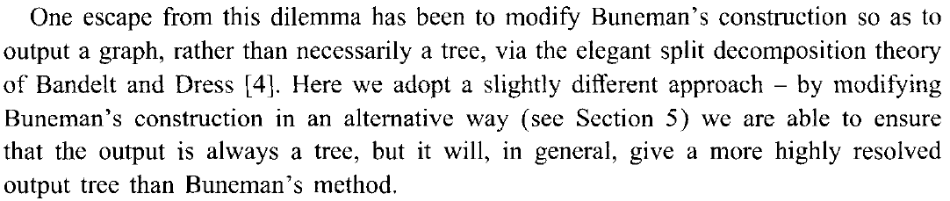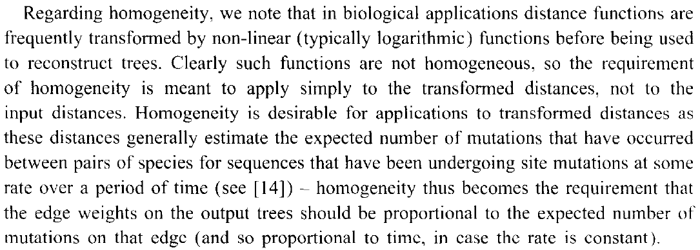

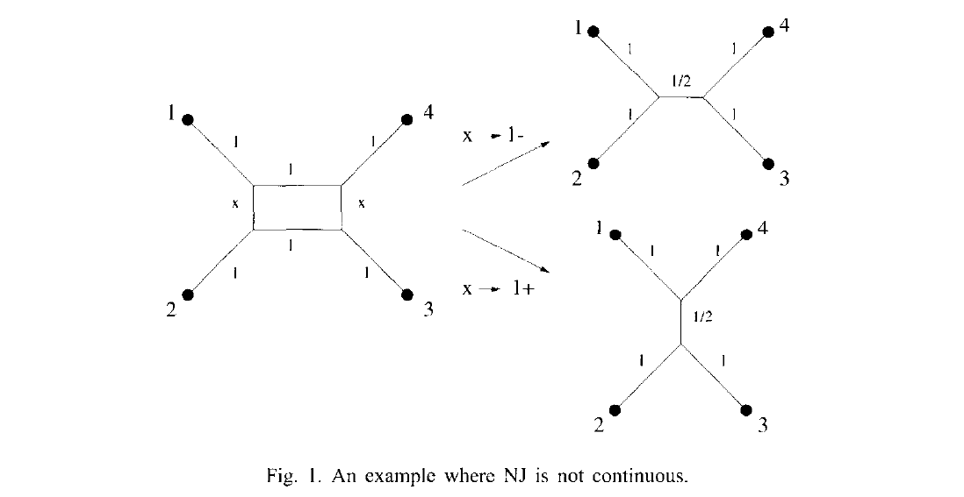

**Split decomposition**

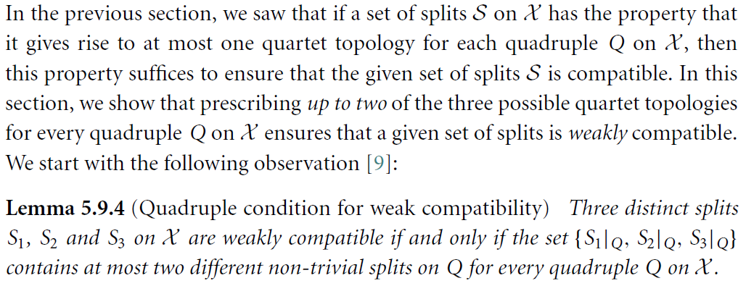 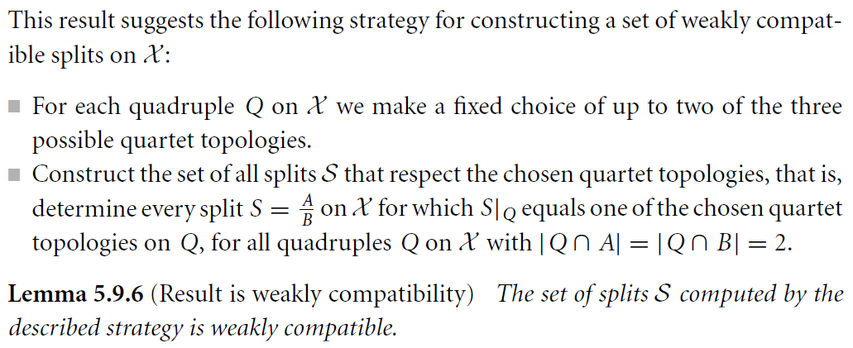

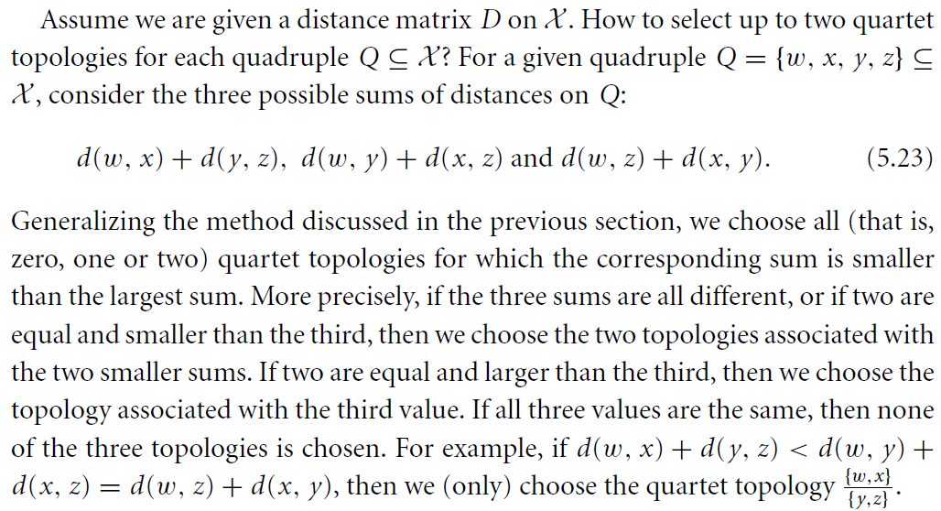 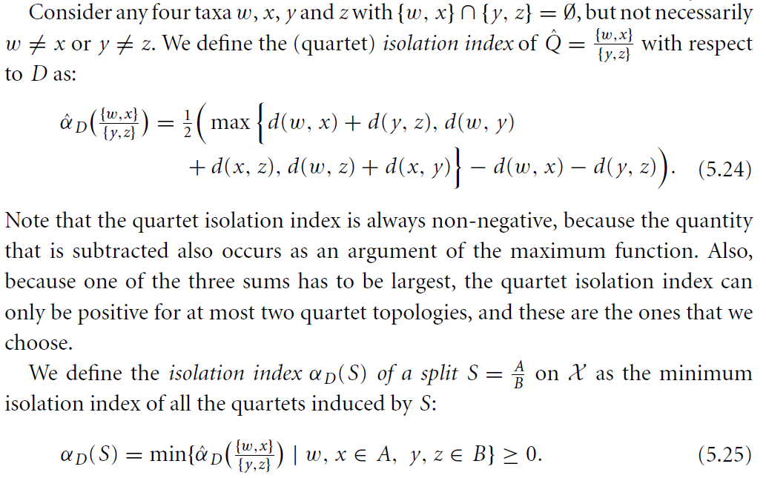

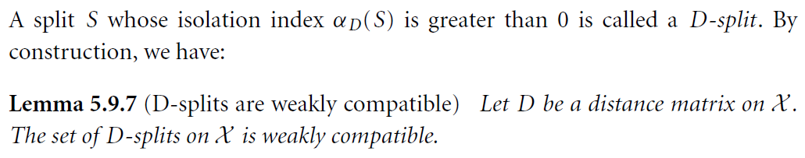

 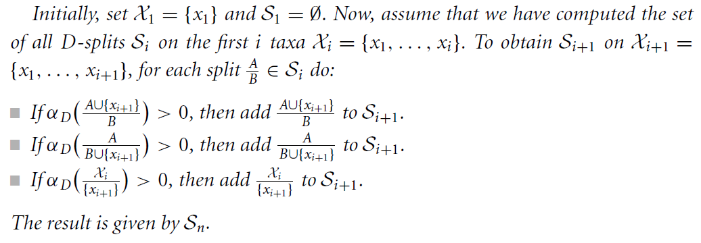 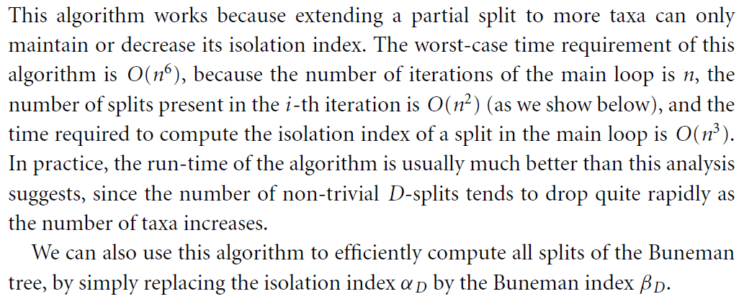

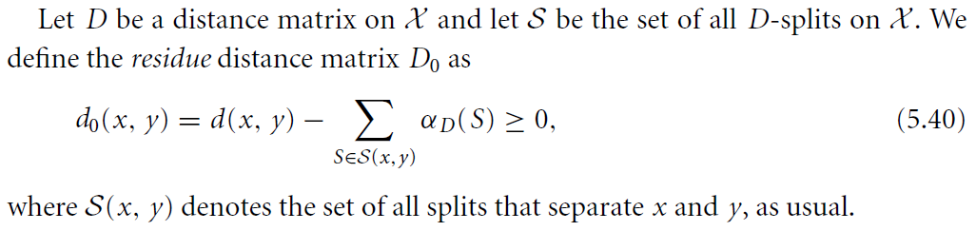 

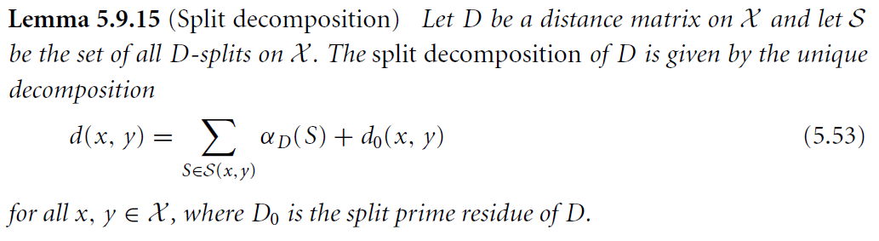 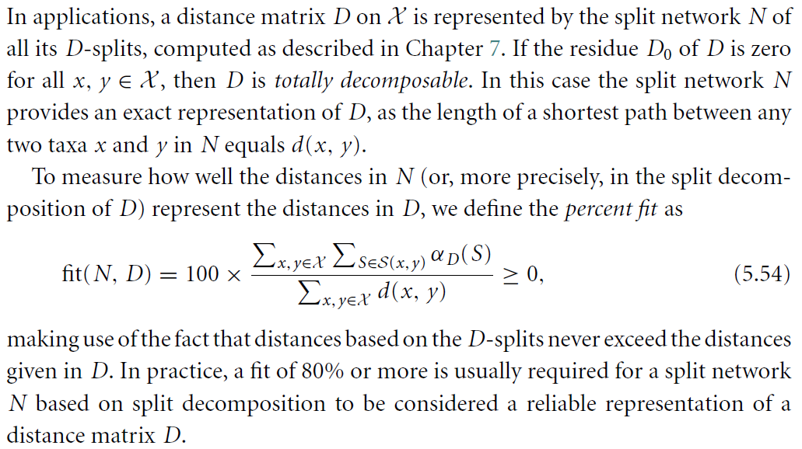

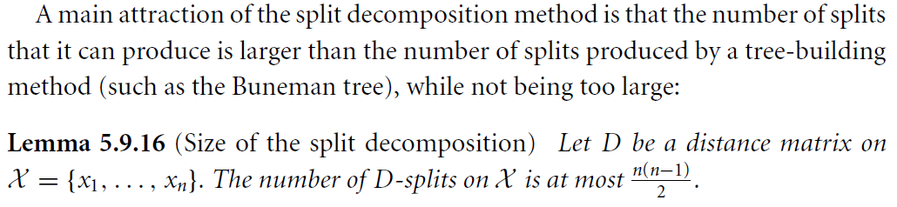

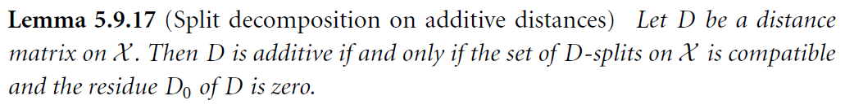

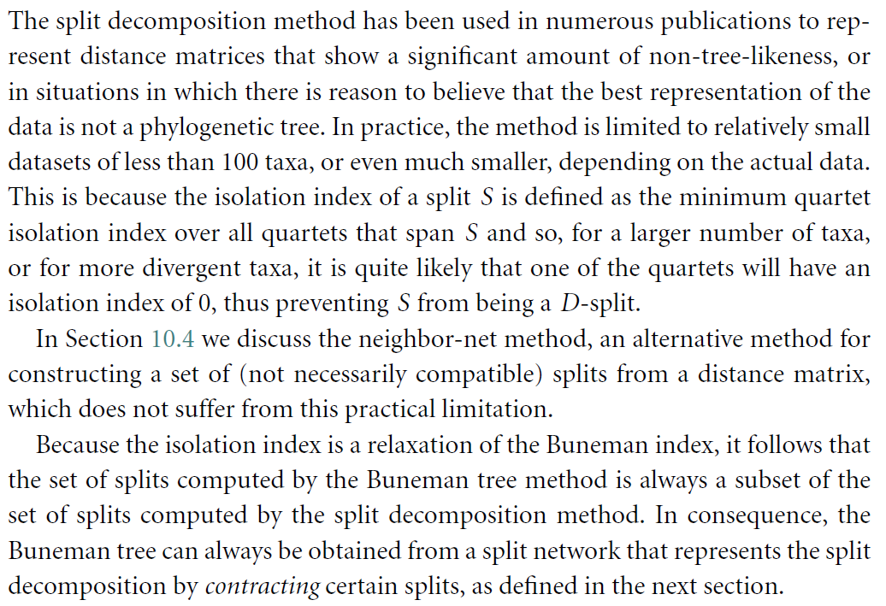

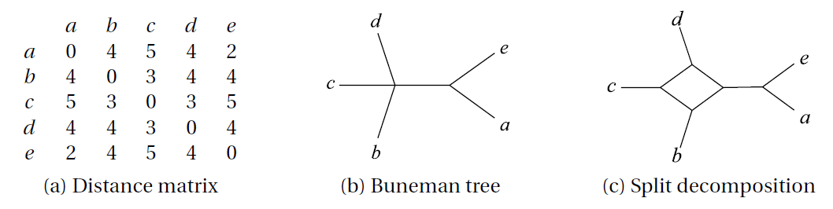

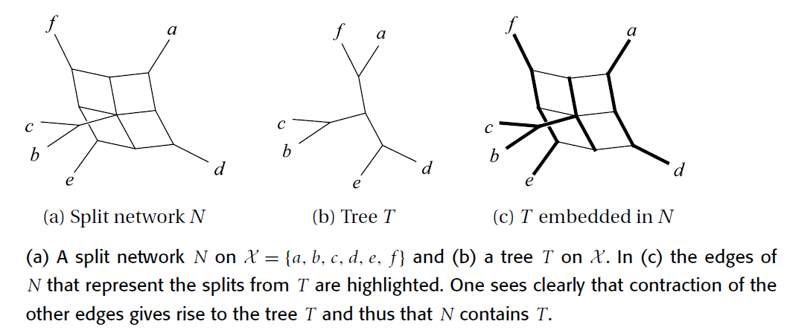

**Neighbor-net**

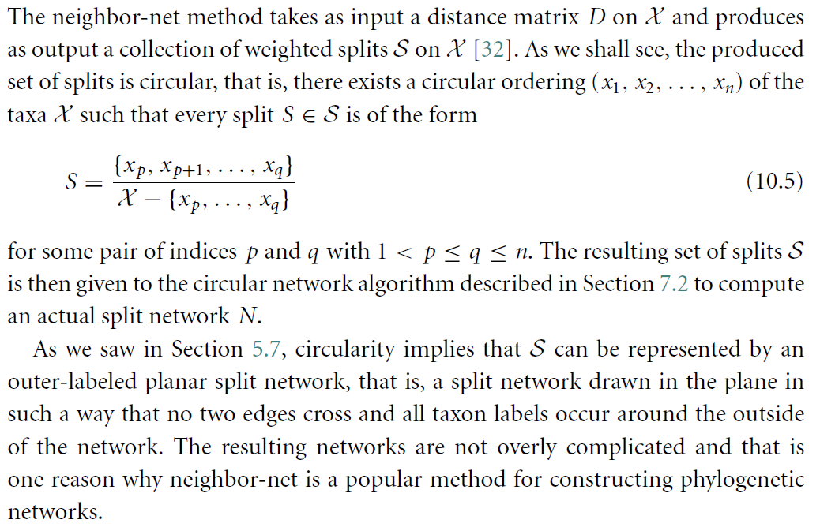 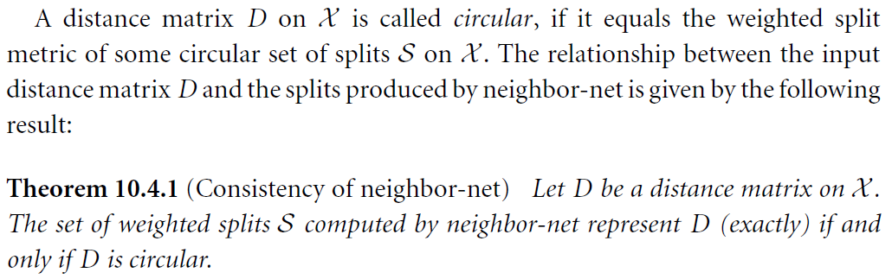 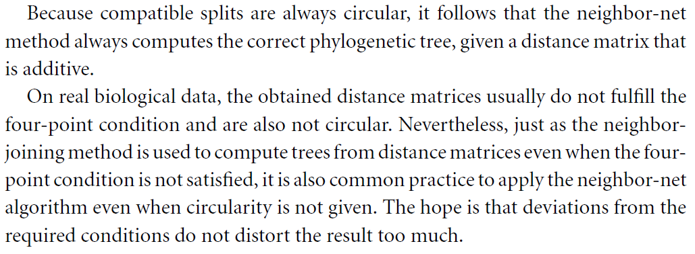

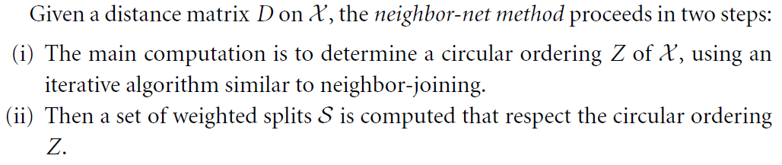

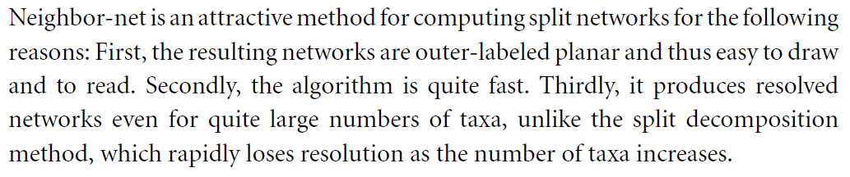

see also [BM2004, BH2023]

**T-theory**

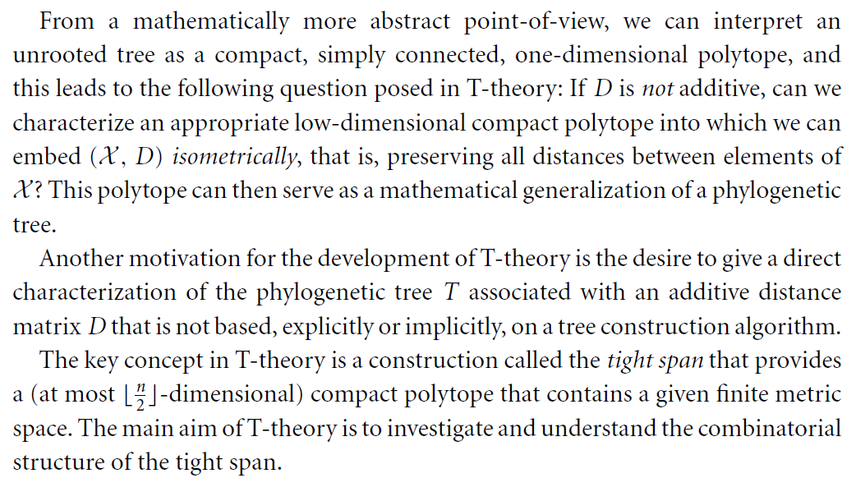

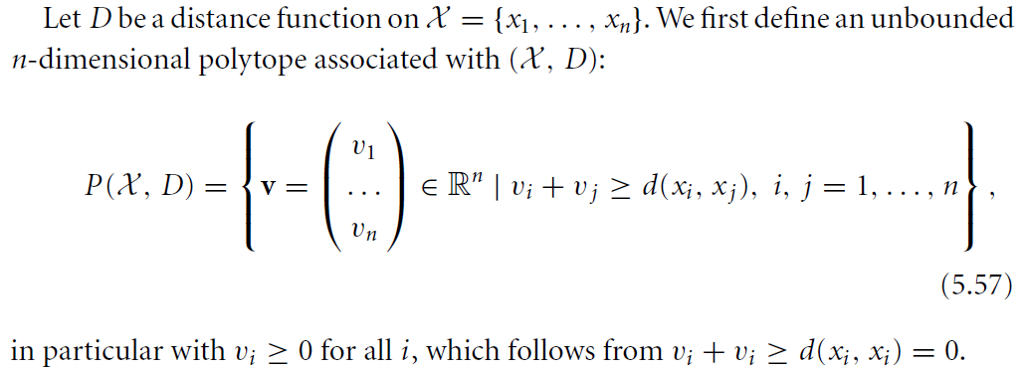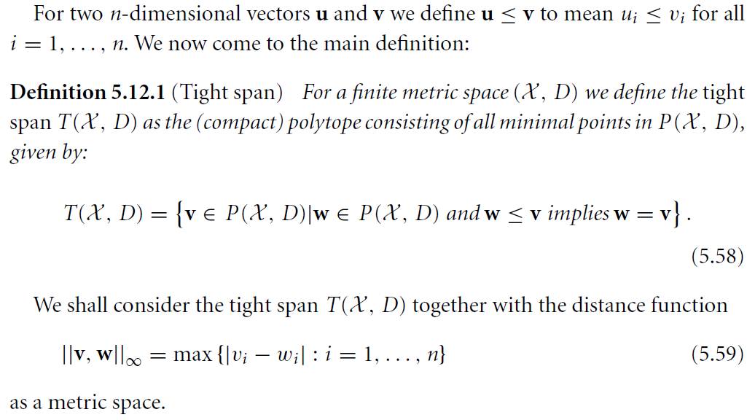

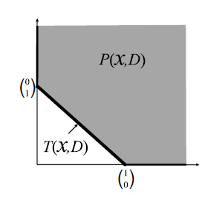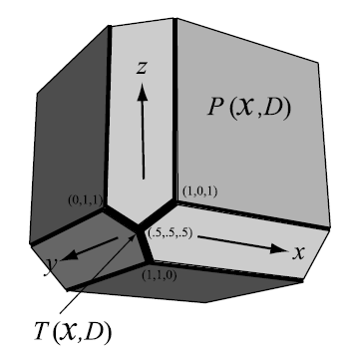

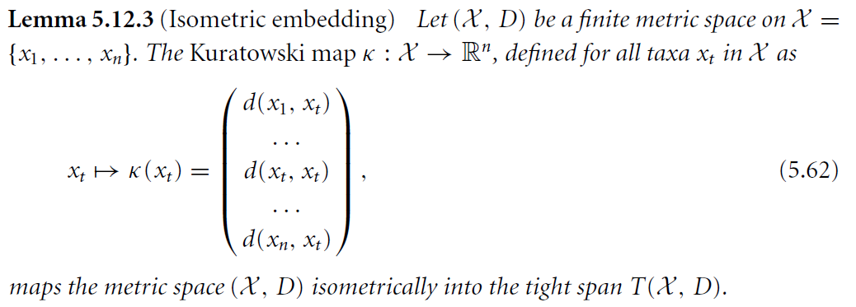

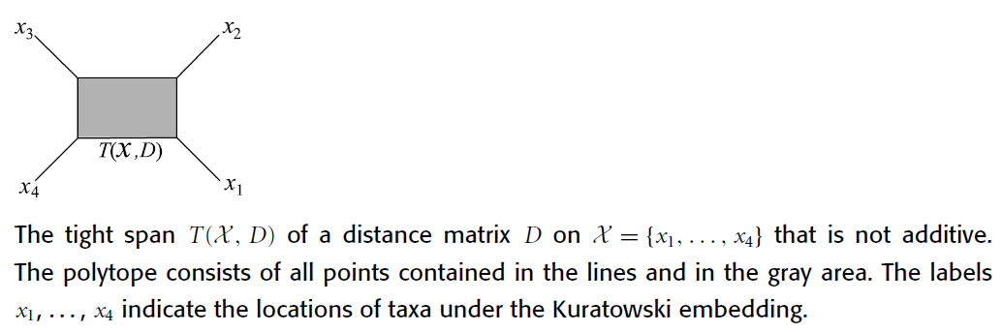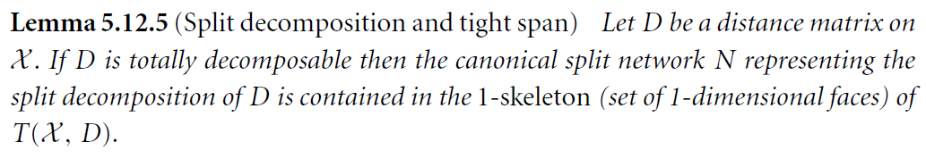

**Phylogenetic networks from splits**

**Convex hull algorithm**

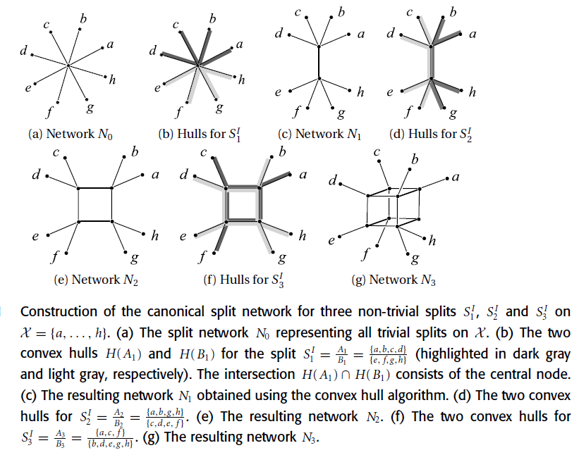

The convex hull algorithm computes the Buneman graph.

from [DHM96]

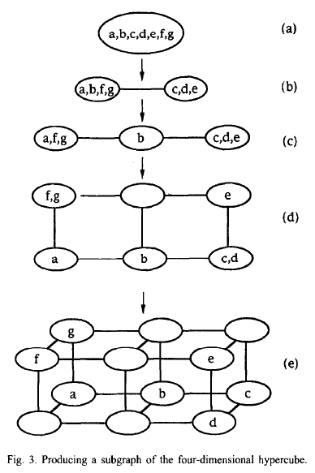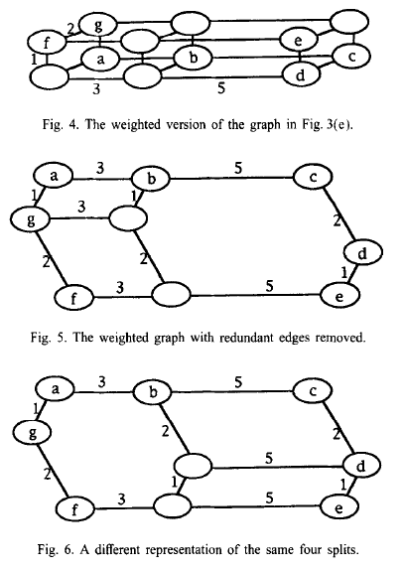

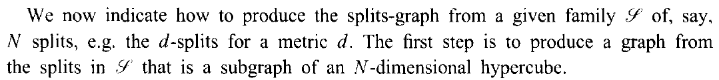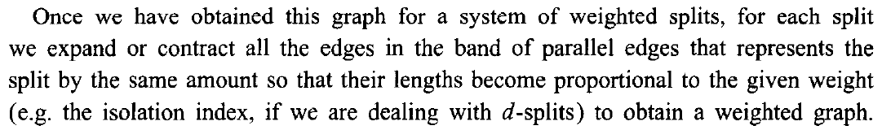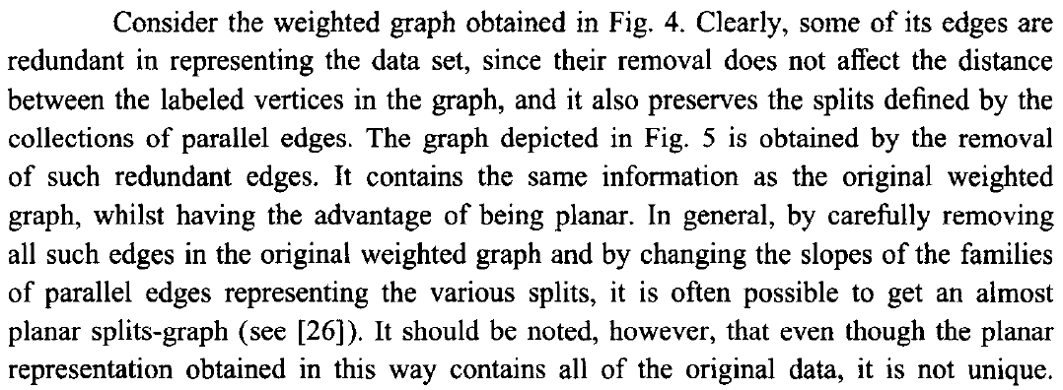

**Circular network algorithm**

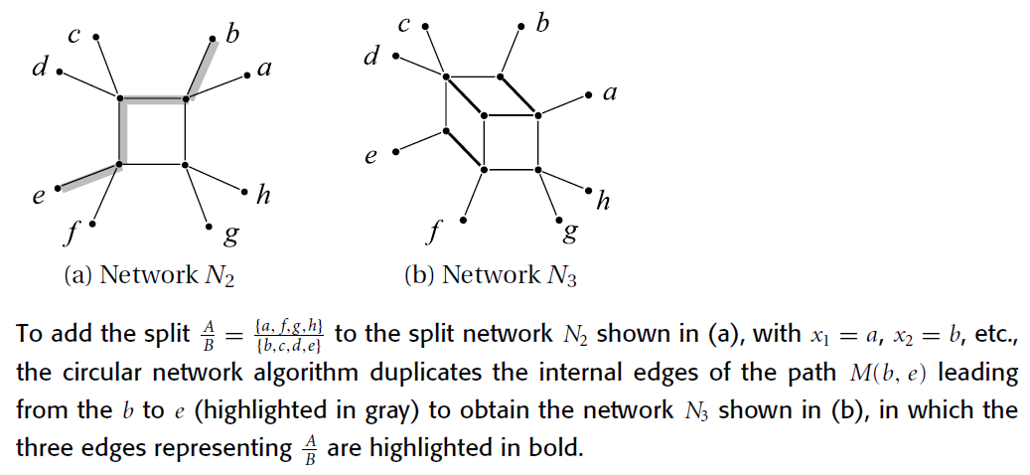

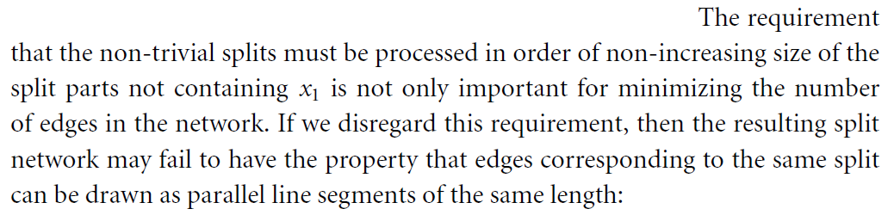

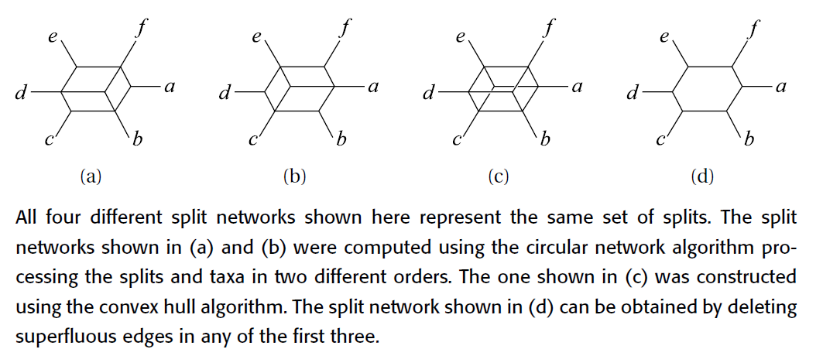

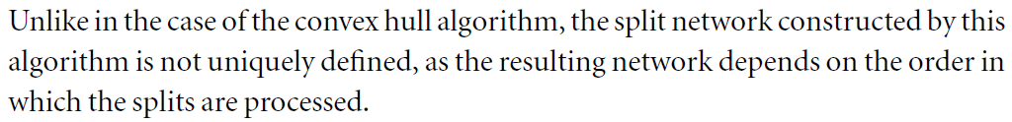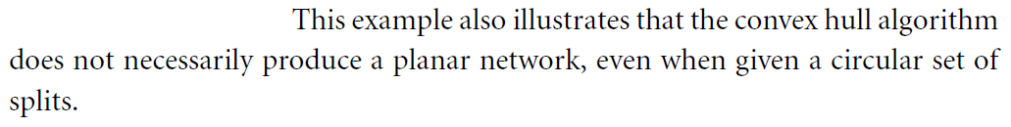

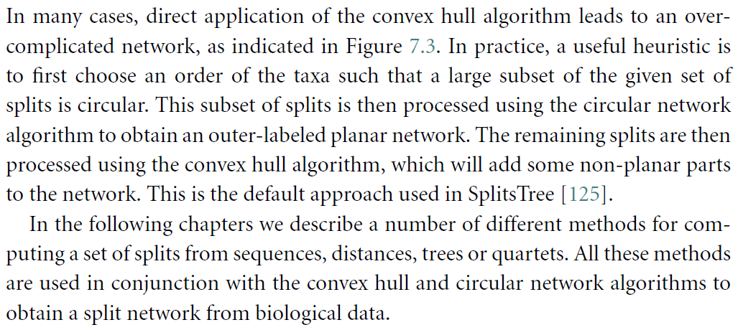

Metric Spaces in Pure and Applied Mathematics

**John Isbell’s contribution**

We consider the category of metric spaces with non-expansive maps.

**Def**. Let $(A,d_{A})$ and $(B,d_{B})$ be metric spaces.

A **non-expansive map** from $A$ to $B$ is a function $f :A→B$ such that

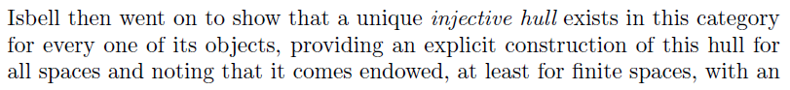 

**Facts**

* There exist **injective metric spaces**, that is  
  a metric space $(X,d)$ such that,  
  for every isometric embedding $α :X↪X^{'}$  
   of $(X,d)$ into another metric space $(X^{'},d^{'})$,  
  there exists a **non-expansive retract $α^{'} :X^{'}→X$** , that is  
   a non-expansive map from $X'$ to $X$ such that $α^{'}∘α=id_{X}$.
* Every metric space $(X,d)$ can be embedded isometrically  
   into an injective metric space $(\hat{X},\hat{d})$.
* Given an isometric embedding $α :X↪\hat{X}$ of a metric space $(X,d)$  
   into an injective metric space $(\hat{X},\hat{d})$,  
  there exists a unique smallest injective subspace $(\overline{X},\overline{d})$ of $(\hat{X},\hat{d})$  
   containing $α(X)$.  
  This subspace depends, up to isometry, only on $(X,d)$.
$$X⊆\overline{X}⊆\hat{X}$$

* The map

$$\begin{matrix}\overline{X}→R^{X} \\ \overline{x}↦h_{\overline{x}} :X→R \\ x↦\overline{d}\left(α\left(x\right),\overline{x}\right)\end{matrix}$$

is an isometric embedding of $(\overline{X},\overline{d})$ into $\left(R^{X},{\left\|⋅,⋅\right\|}_{∞}\right)$ where

$${\left\|f,g\right\|}_{∞}≔\sup_{x ∈ X}{ \left|f\left(x\right)-g(x)\right|}$$

* Its image coincides with

$$T\left(X,d\right)≔\left\{ f∈R^{X} | f\left(x\right)=\sup_{y ∈ X}{ \left(d\left(x,y\right)-f\left(y\right)\right)}, ∀ x∈X \right\}$$

that is called the **tight span** of $\left(X,d\right)$.

* This embedding identifies $X$ with the set

$${\left\{ \begin{matrix}h_{x} :X→R \\ y↦d\left(y,x\right)\end{matrix} \right\}}_{x ∈ X}$$

and hence with the subset of $T\left(X,d\right)$

$$T^{0}\left(X,d\right)≔\left\{ f∈T\left(X,d\right) | f\left(X\right)∋0 \right\}$$

* This construction also identifies $T\left(X,d\right)$ with a subset of the convex set

$$P\left(X,d\right)≔\left\{ f∈R^{X} | f\left(x\right)+f\left(y\right)≥d\left(x,y\right), ∀ x,y∈X \right\}$$

more precisely, it identifies it with the set of minimal maps in $P\left(X,d\right)$, relative to the partial order inherithed from $R^{X}$

$$f≤g ⟺ f\left(x\right)≤g\left(x\right), ∀x∈X$$

* $T\left(X,d\right)$ is contractible.  
  There exists a continous family of non-expansive maps

$$f_{t} :T\left(X,d\right)→T\left(X,d\right), t∈[0,1]$$

such that $f_{0}$ is the identity and the image of $f_{1}$ is a point.

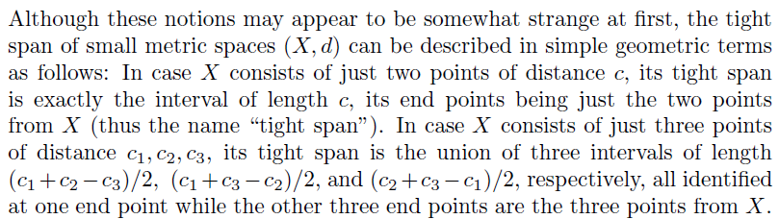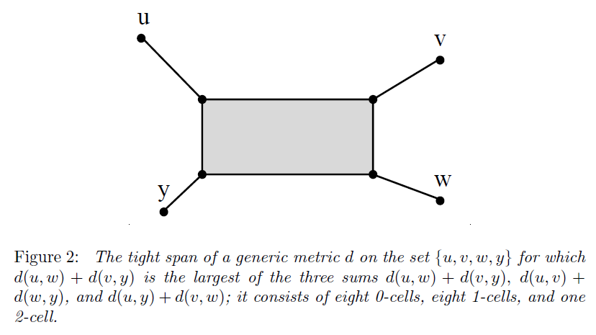

The construction works not only for metrics,  
 but also for maps $D$ from $P_{fin}\left(X\right)$ to $\underline{R}≔R∪\left\{-∞\right\}$

$$P\left(X,D\right)≔\left\{ f∈R^{X} :\sum_{x ∈ Y}{f\left(x\right)}≥D\left(Y\right), ∀ Y∈P_{fin}\left(X\right) \right\}$$

$$T\left(X,D\right)≔\left\{ f∈R^{X} : f\left(x\right)=\sup_{Y ∈ P_{fin}\left(X-\{x\}\right)}\left(D\left(Y∪\left\{x\right\}\right)\right)-\sum_{y ∈ Y}{f\left(y\right)} \right\}$$

In the case of a metric $d$, we can define $D_{d} : P_{fin}\left(X\right)→\underline{R}$ as

$$D_{d}(Y)≔\left\{ \begin{matrix}d\left(x,y\right) , & Y=\{x,y\} \\ -∞ , & otherwise\end{matrix}\right.$$

and we observe that the new definitions are consistent



$$P\left(X,D_{d}\right)=P\left(X,d\right) , T\left(X,D_{d}\right)=T\left(X,d\right)$$

**Phylogenetic analysis**

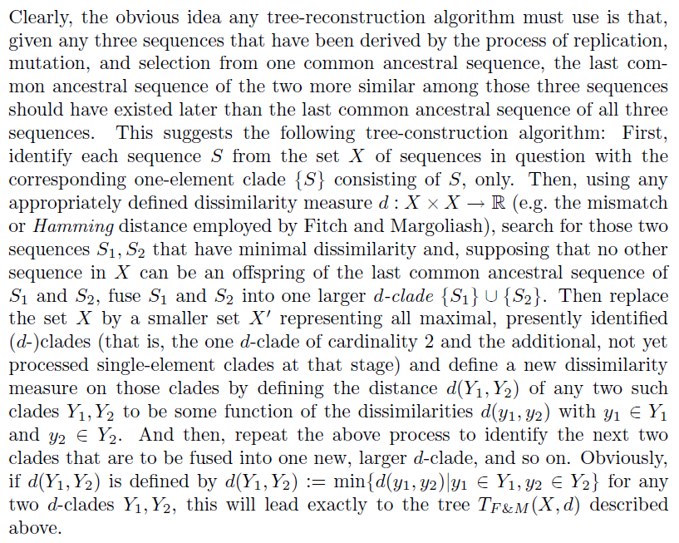

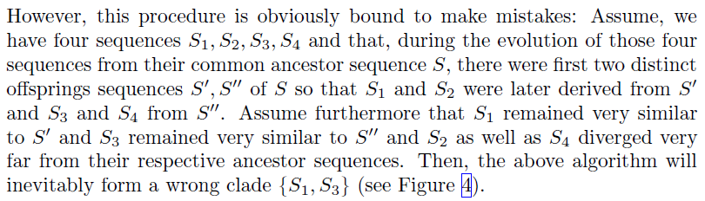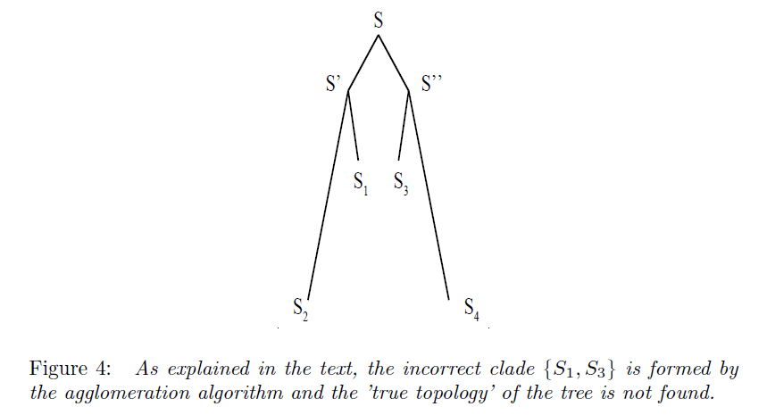

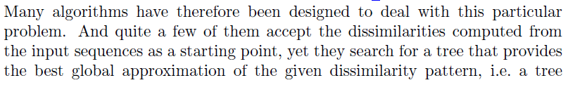 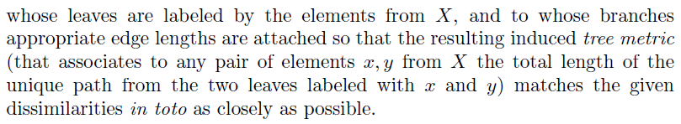

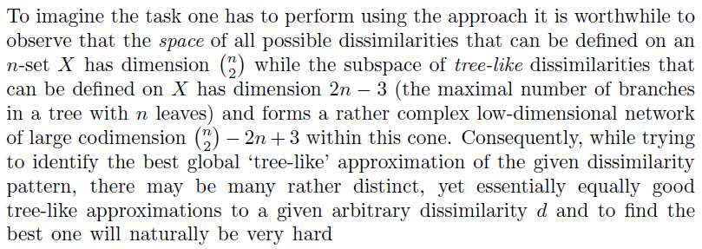

**Tree reconstruction and the tight span**

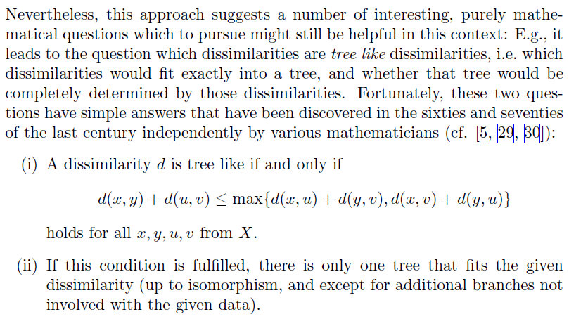 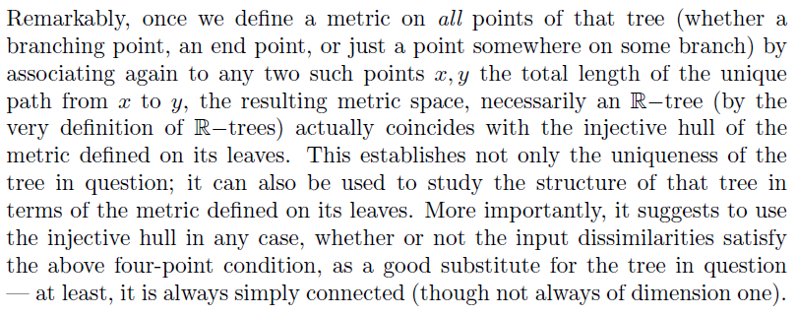

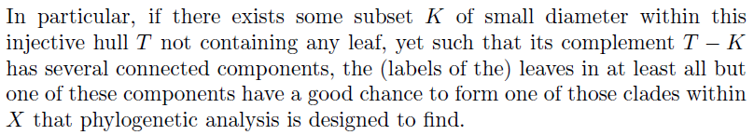

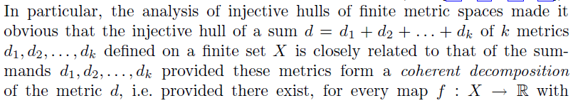 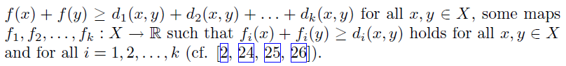

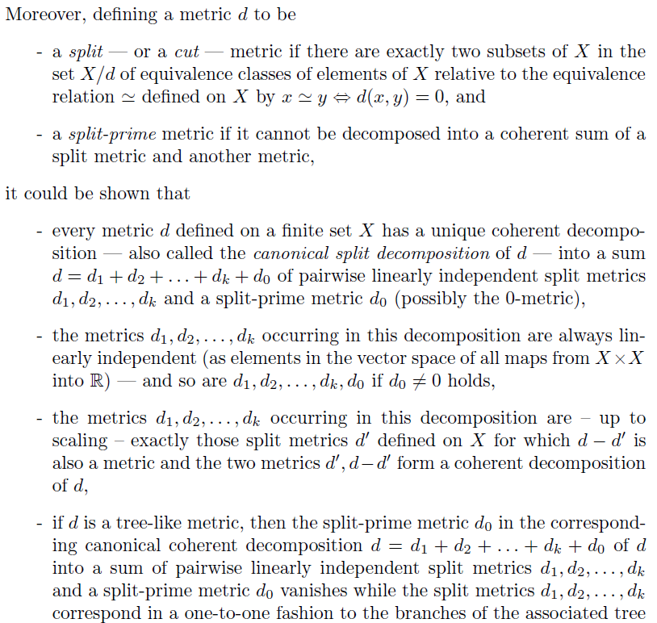

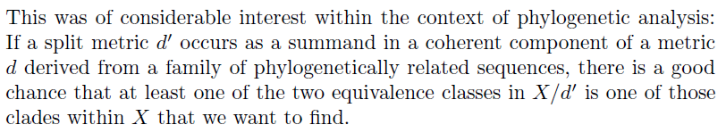

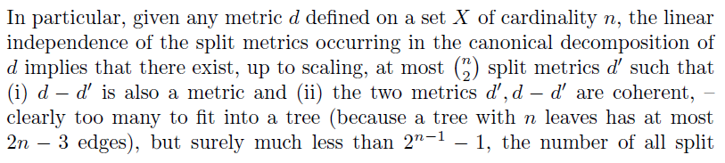 

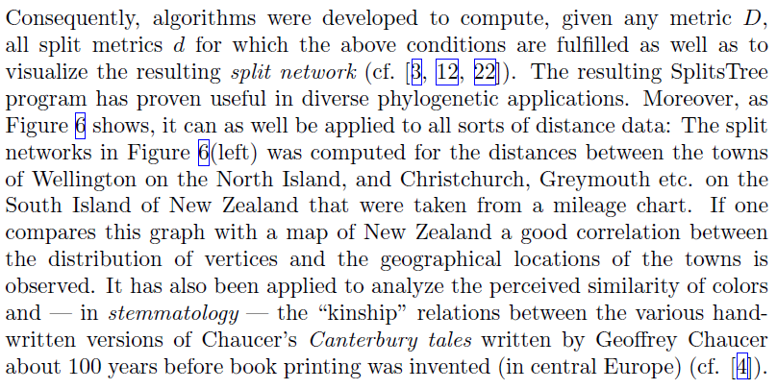

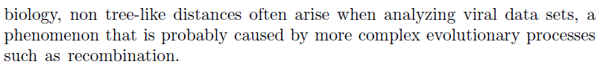

**Back to mathematics and quadratic forms**

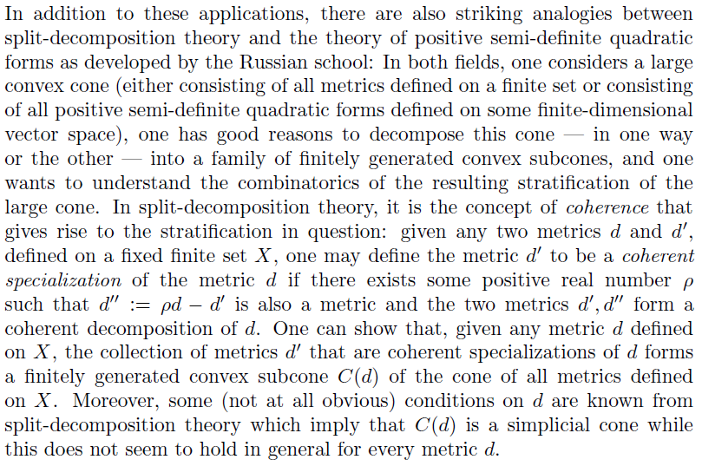

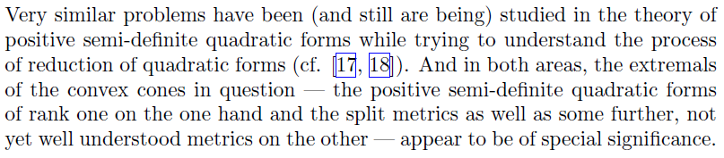

1. * also called branch or link